**Appendix 1: Two-Link Planar Control simulation results**

Contents

Simulation parameters 1

Robot parameters 1

Realistic simulation parameters 1

Simulation results (ideal) 2

PD Joint control 2

Step response 2

Sine wave response 4

Observations 5

PID Joint control 5

Step response 5

Sine wave response 6

Observations 7

Pole Placement Control 7

Step response 8

Sine wave response 9

Observations 10

Pole Placement Control with feedforward disturbance terms 10

Step response 10

Sine wave response 11

Observations 12

PD+Gravity compensation Joint control 12

Step response 13

Sine wave response 14

Observations 15

Inverse dynamics control 15

Step response 15

Sine wave response 16

Observations 17

Simulation results (realistic) – No parameter deviation 18

PD Joint control 18

Step response 18

Sine wave response 19

Observations 20

PID Joint control 20

Step response 20

Sine wave response 22

Observations 23

Pole Placement Control 23

Step response 23

Sine wave response 25

Observations 25

Pole Placement Control with feedforward disturbance terms 26

Step response 26

Sine wave response 27

Observations 28

PD+Gravity compensation Joint control 28

Step response 29

Sine wave response 30

Observations 31

Inverse dynamics control 31

Step response 32

Sine wave response 33

Observations 34

Robust control 34

Step response 35

Sine wave response 36

Observations 37

Simulation results (realistic) – with parameter deviation 38

Pole Placement Control with feedforward disturbance terms 38

Step response 38

Sine wave response 39

Observations 40

PD+Gravity compensation Joint control 41

Step response 41

Sine wave response 42

Observations 43

Inverse dynamics control 43

Step response 43

Sine wave response 45

Observations 46

Robust control 46

Step response 46

Sine wave response 48

Observations 49

# Simulation parameters

## Robot parameters

Table 1: Robot parameter

|  |  |
| --- | --- |
| Parameter | Value |
| g | 9.8066 (in Y-direction) |
| Link density | 3700 kg/m3 |
| Link 1 dimensions (x*y*z) | 0.3m*0.05m*0.05m |
| Link 2 dimensions (x*y*z) | 0.15m*0.05m*0.05m |
| m1 | 2.775 kg |
| m2 | 1.3875 kg |
| b1 | 0.01 |
| b2 | 0.01 |
| Initial values ( | All zeros |

## Realistic simulation parameters

* Gaussian measurement noise is added to joint position with standard deviation equal to position precision
* Only joint noise is added since it will propagate through the integrals to velocity and acceleration and only position sensor is used.
* A first-order low-pass filter is added to smooth joint position measurements (introduces some lag)

Table 2: Simulation parameters (realistic)

|  |  |
| --- | --- |
| Parameter | Value |
| Sampling time | 1ms |
| Maximum velocity |  |
| Maximum joint 1 torque | 20 Nm |
| Maximum joint 2 torque | 10 Nm |
| Joint position precision |  |
| Robot parameters deviation (mass, length, viscosity)  (Used in the dynamics terms of some controllers) |  |

# Simulation results (ideal)

## PD Joint control

Table 3: PD gains

|  |  |  |  |
| --- | --- | --- | --- |
| Parameter | Value | Parameter | Value |
|  | 30 |  | 7 |
|  | 2.5 |  | 0.5 |

### Step response

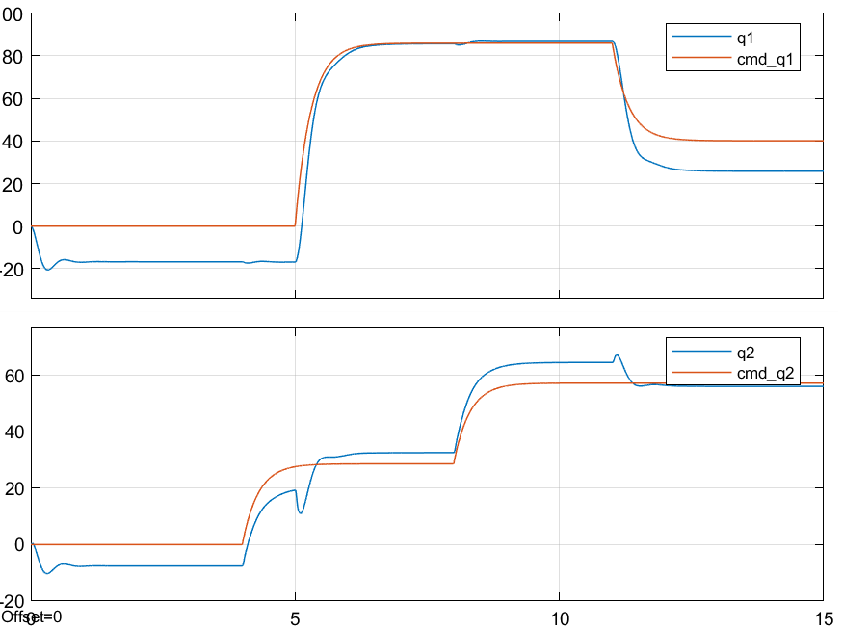

Figure 1: PD control ideal system step response - joint position

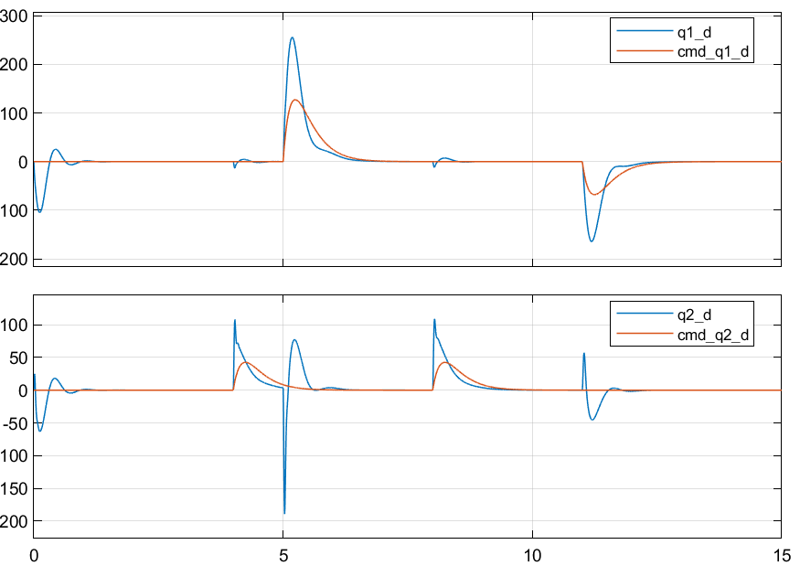

Figure 2: PD control ideal system step response - joint velocity

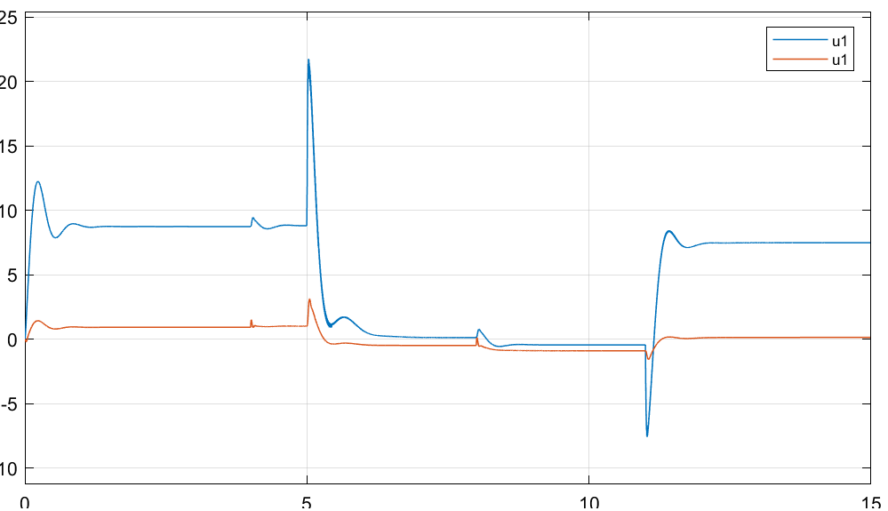

Figure 3: PD control ideal system step response - joint input torque

### Sine wave response

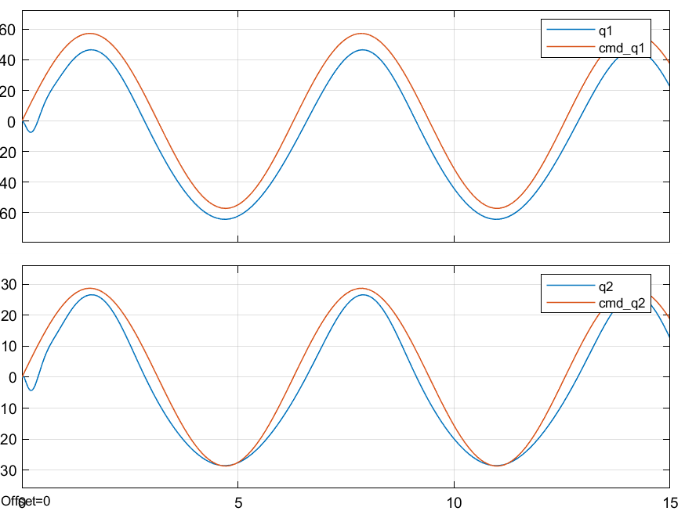

Figure 4: PD control ideal system sine wave response - joint position

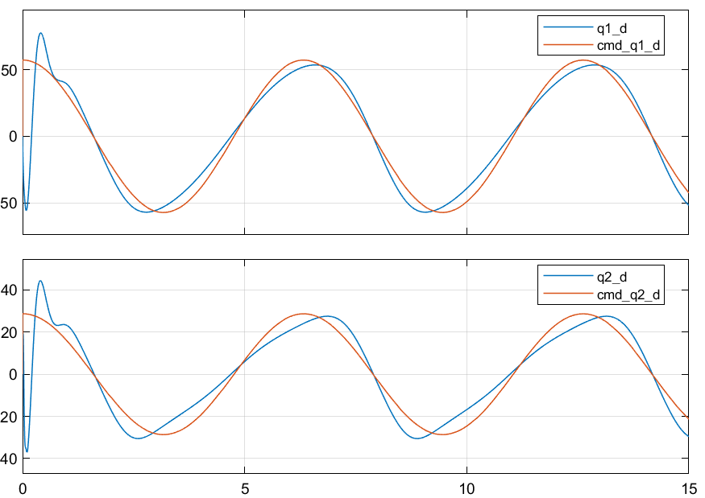

Figure 5: PD control ideal system sine wave response - joint velocity

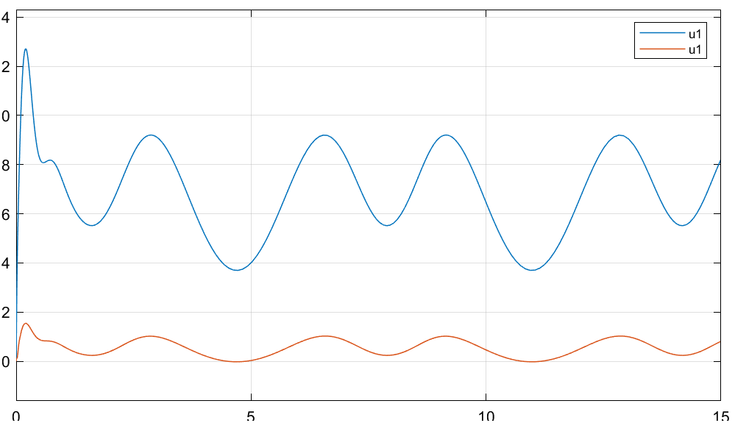

Figure 6: PD control ideal system sine wave response - joint input torque

### Observations

* Nonzero steady-state and tracking errors as expected

## PID Joint control

Table 4: PID gains

|  |  |  |  |
| --- | --- | --- | --- |
| Parameter | Value | Parameter | Value |
|  | 30 |  | 7 |
|  | 2.5 |  | 0.5 |
|  | 20 |  | 15 |

### Step response

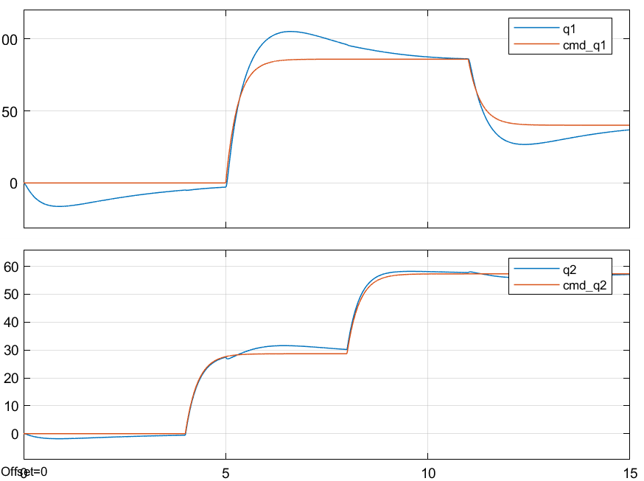

Figure 7: PID control ideal system step response - joint position

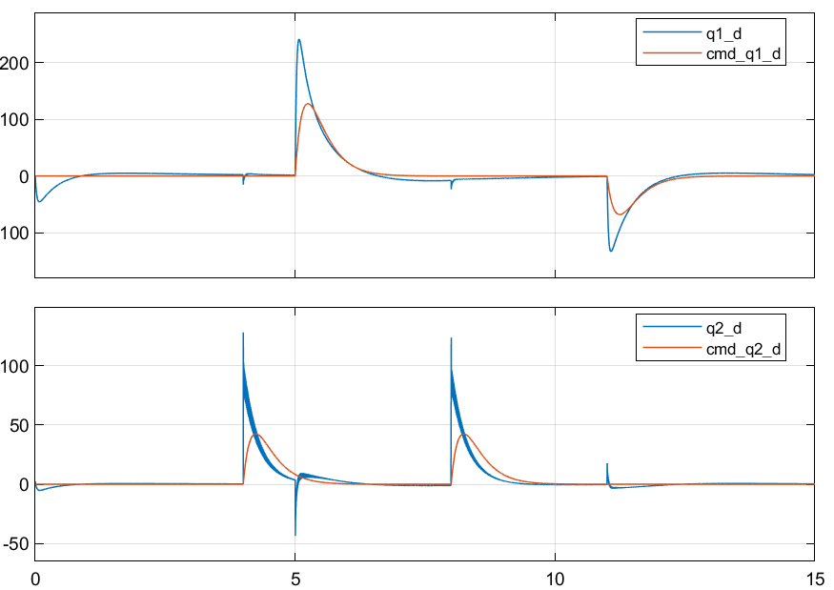

Figure 8: PID control ideal system step response - joint velocity

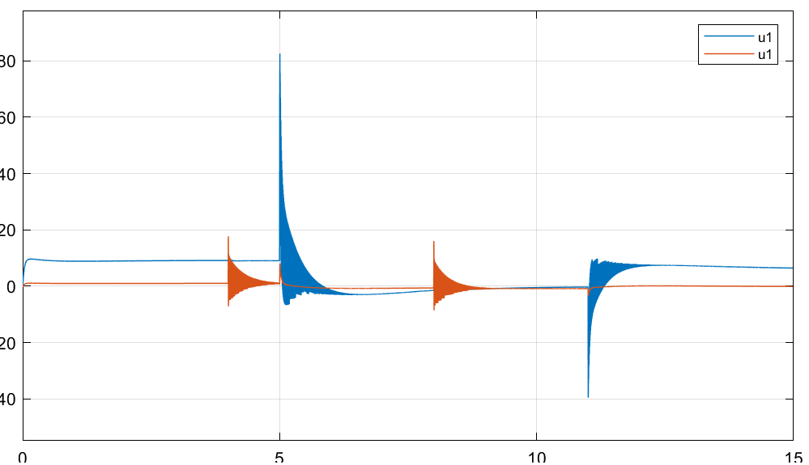

Figure 9: PID control ideal system step response - joint input torque

### Sine wave response

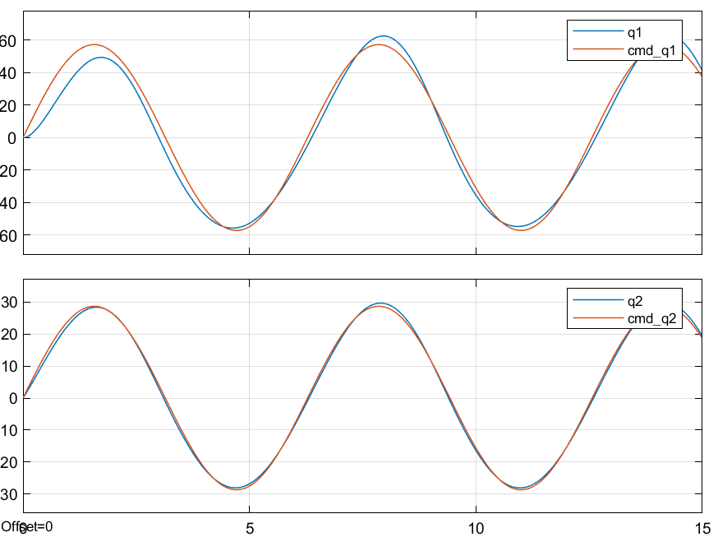

Figure 10: PID control ideal system sine wave response - joint position

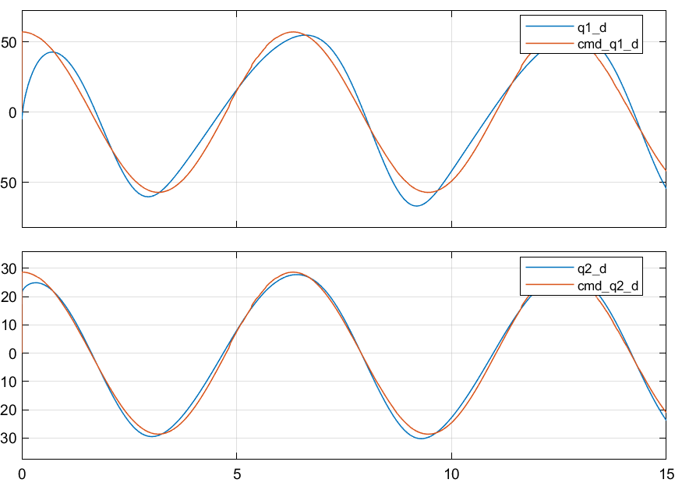

Figure 11: PID control ideal system sine wave response - joint velocity

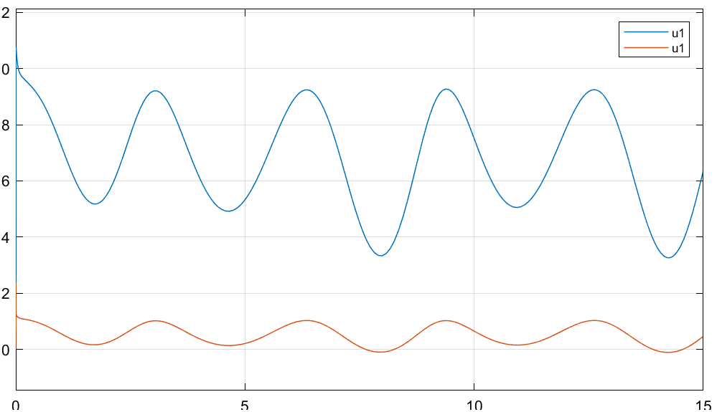

Figure 12: PID control ideal system sine wave response - joint input torque

### Observations

* Steady-state goes to zero when given enough time
* Tracking error is still not zero due to response lag
* High-magnitude and high frequency commanded torques at the step edge

## Pole Placement Control

Table 5: Pole values and feedback gain- ideal

|  |  |
| --- | --- |
| Parameter | Value |
| poles | [-90, -80, -70, -10.8] |
|  |  |

### Step response

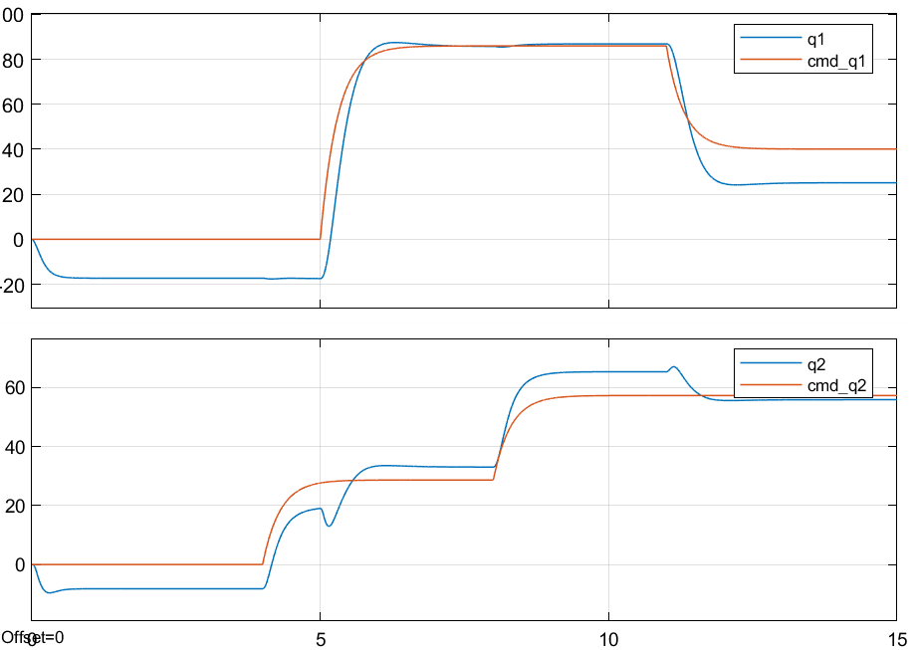

Figure 13: Pole placement control ideal system step response - joint position

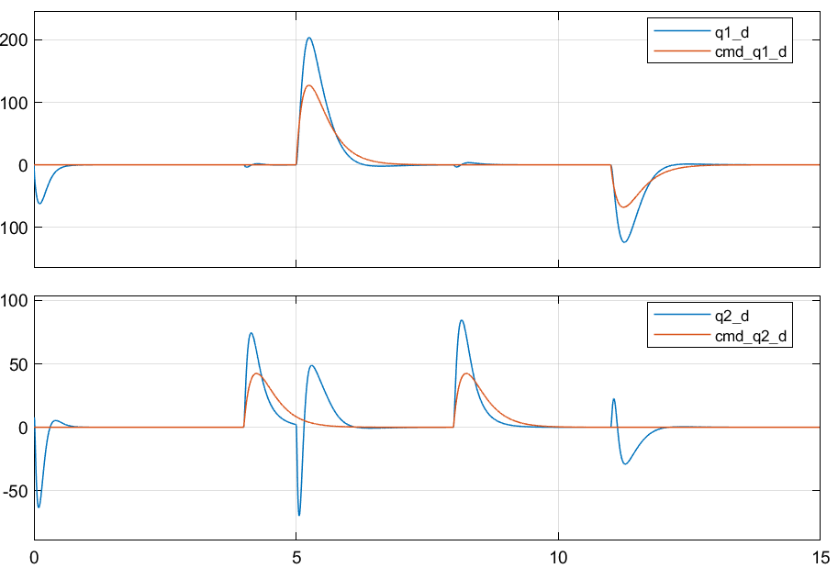

Figure 14: Pole placement control ideal system step response - joint velocity

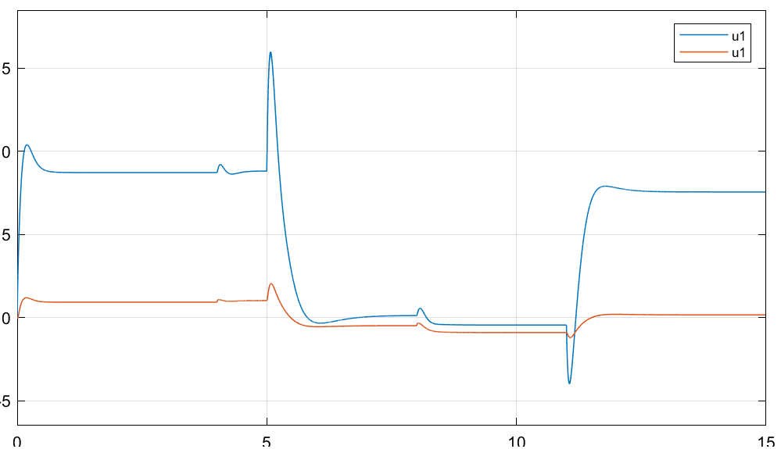

Figure 15: Pole placement control ideal system step response - joint input torque

### Sine wave response

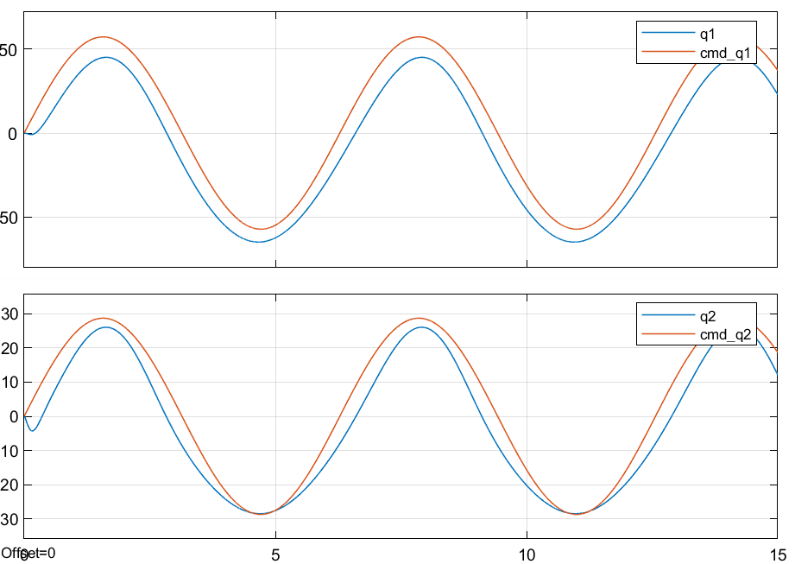

Figure 16: Pole placement control ideal system sine wave response - joint position

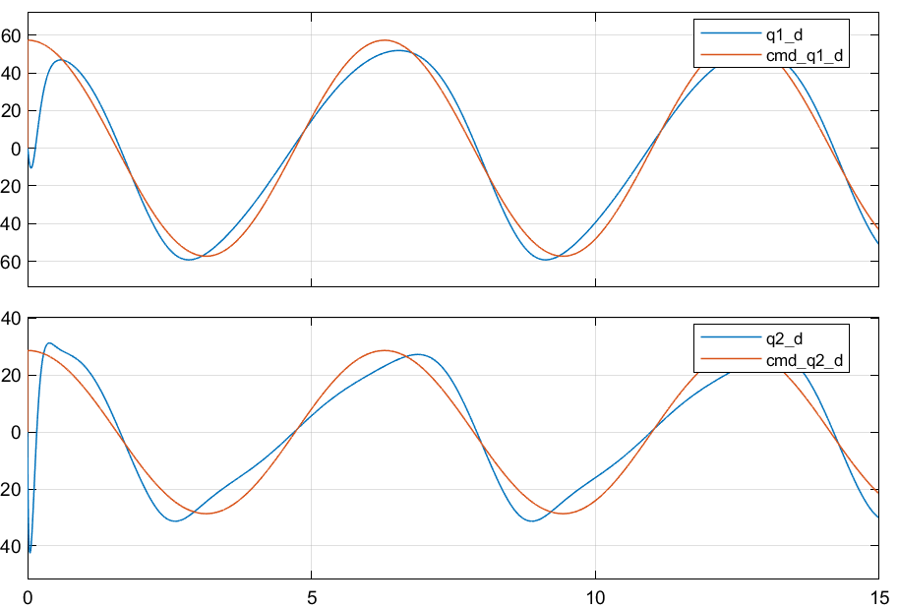

Figure 17: Pole placement control ideal system sine wave response - joint velocity

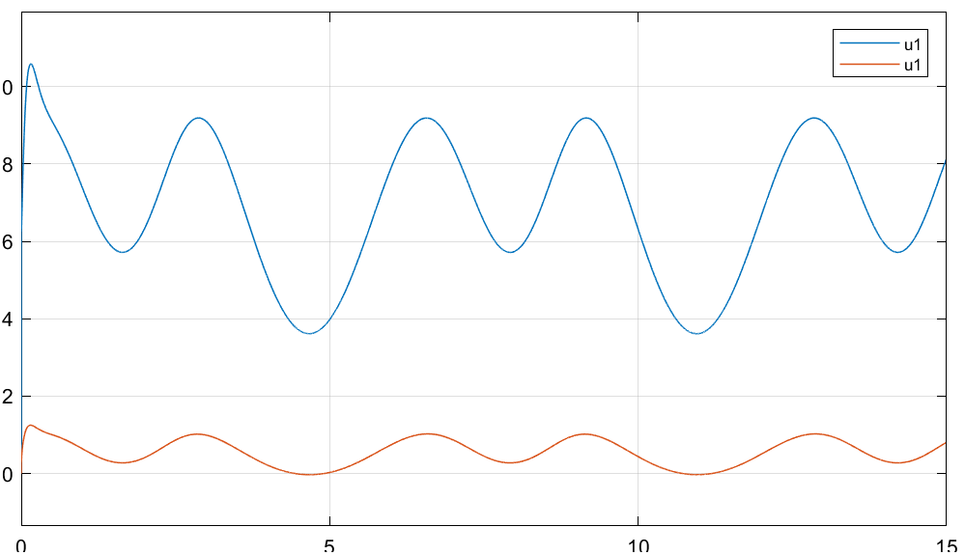

Figure 18: Pole placement control ideal system sine wave response - joint input torque

### Observations

* Nonzero Steady-state and tracking error

## Pole Placement Control with feedforward disturbance terms

### Step response

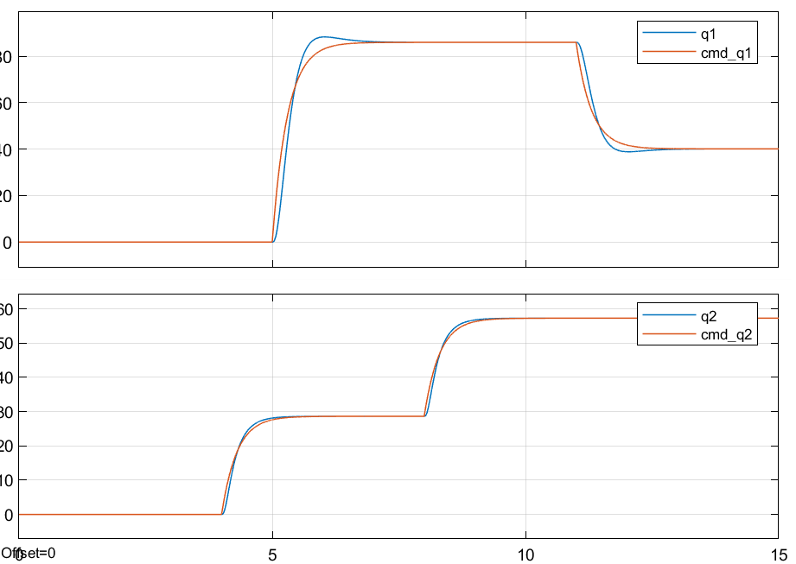

Figure 19: Pole placement+D control ideal system step response - joint position

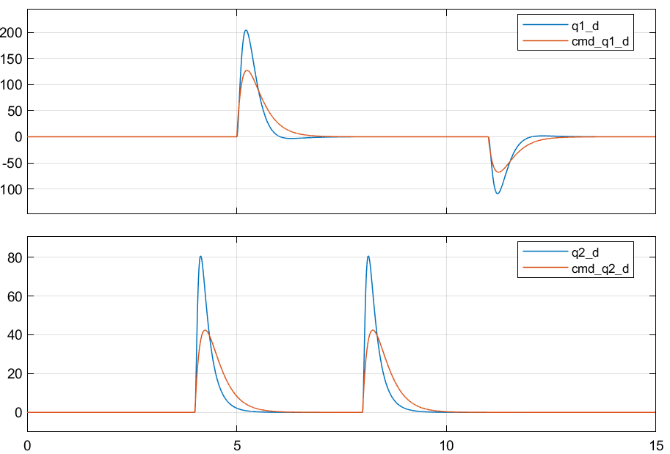

Figure 20: Pole placement+D control ideal system step response - joint velocity

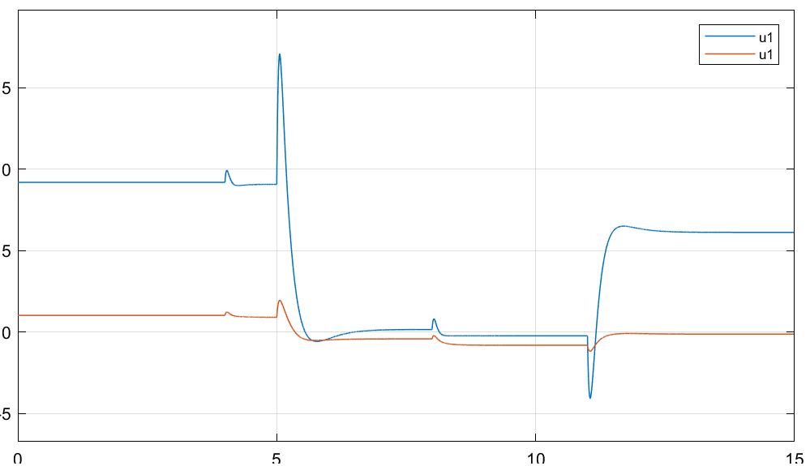

Figure 21: Pole placement+D control ideal system step response - joint input torque

### Sine wave response

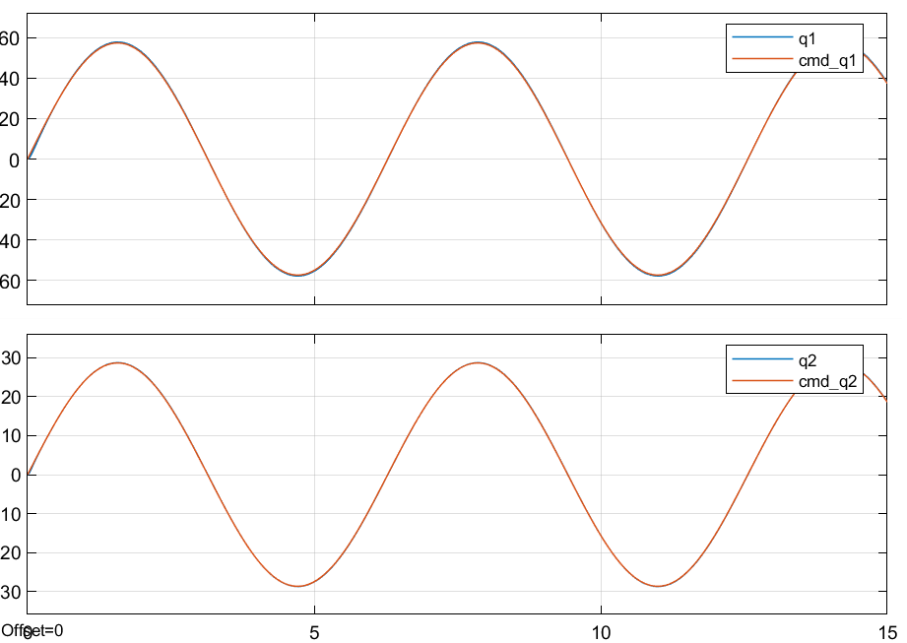

Figure 22: Pole placement+D control ideal system sine wave response - joint position

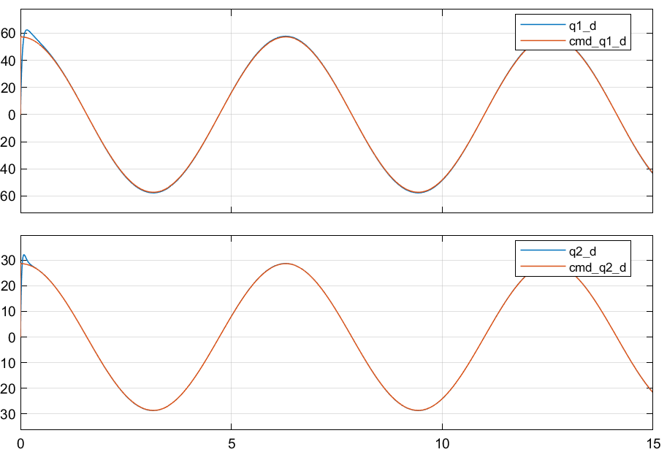

Figure 23: Pole placement+D control ideal system sine wave response - joint velocity

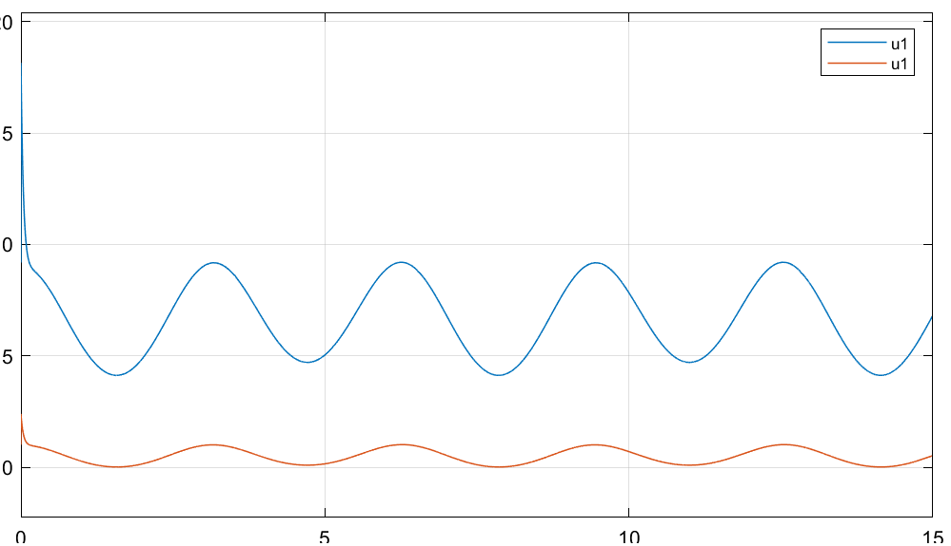

Figure 24: Pole placement+D control ideal system sine wave response - joint input torque

### Observations

* Zero Steady-state and tracking errors.
* Slight overshoot in position and big overshoot in velocity response

## PD+Gravity compensation Joint control

Table 6: PD gains for Gravity+PD control – Ideal system

|  |  |  |  |
| --- | --- | --- | --- |
| Parameter | Value | Parameter | Value |
|  | 15 |  | 3.5 |
|  | 2.5 |  | 0.5 |

### Step response

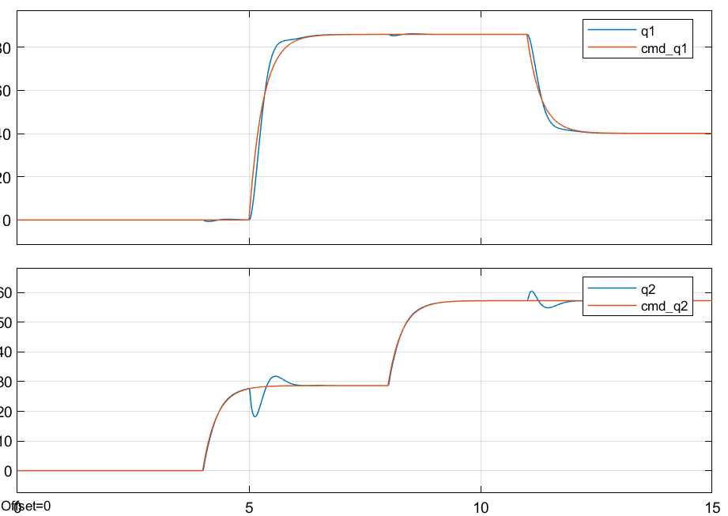

Figure 25: GRAVITY+PD control ideal system step response - joint position

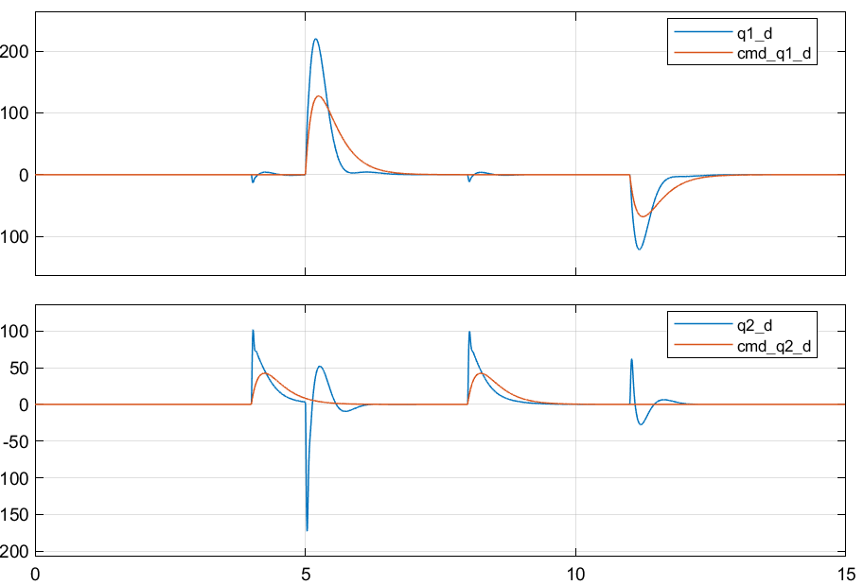

Figure 26: GRAVITY+PD control ideal system step response - joint velocity

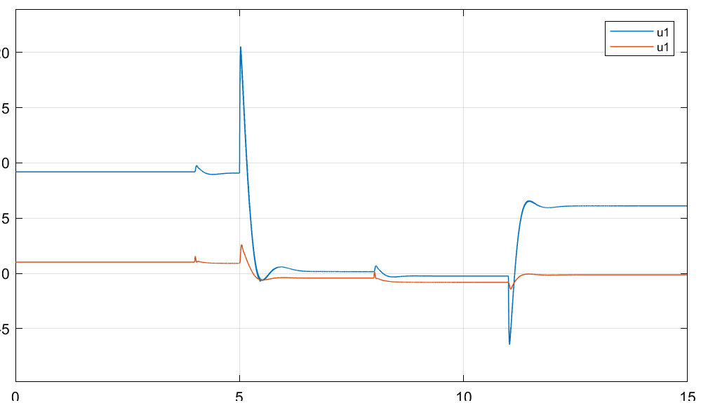

Figure 27: GRAVITY+PD control ideal system step response - joint input torque

### Sine wave response

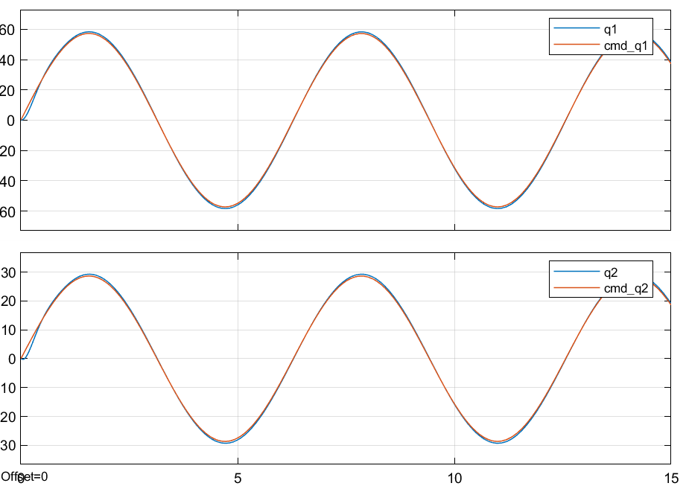

Figure 28: GRAVITY+PD control ideal system sine wave response - joint position

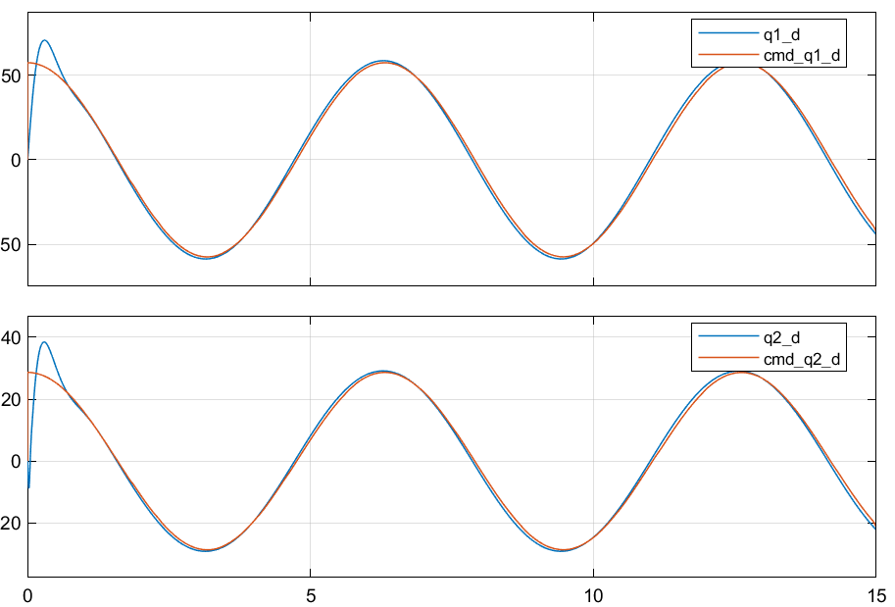

Figure 29: GRAVITY+PD control ideal system sine wave response - joint velocity

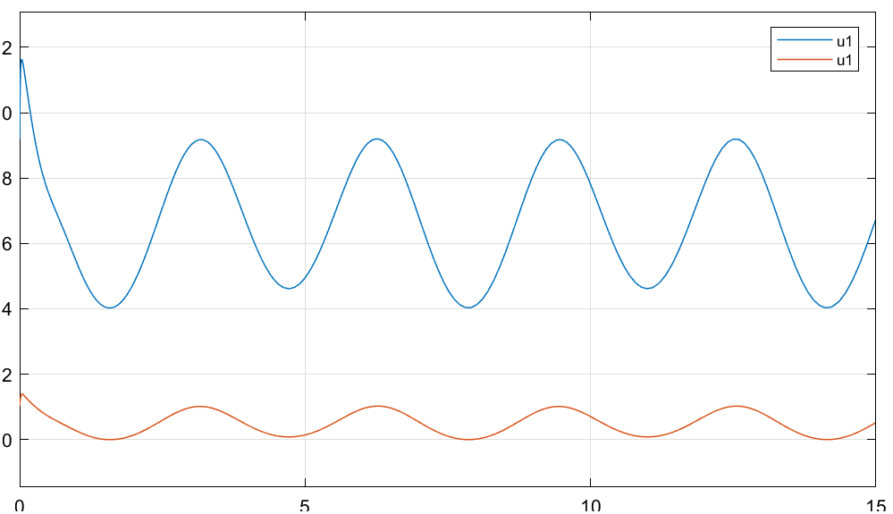

Figure 30: GRAVITY+PD control ideal system sine wave response - joint input torque

### Observations

* Steady-state converges close to zero and tracking error is within 1 degree
* Huge improvements compared to PD-only control
* Increasing PD gains will result in fast settling time and zero steady-state errors but will introduce high-frequency oscillations in commanded torques.

## Inverse dynamics control

Table 7: PD gains – Inverse control – Ideal system

|  |  |  |  |
| --- | --- | --- | --- |
| Parameter | Value | Parameter | Value |
|  | 25 |  | 50 |
|  | 12 |  | 15 |

### Step response

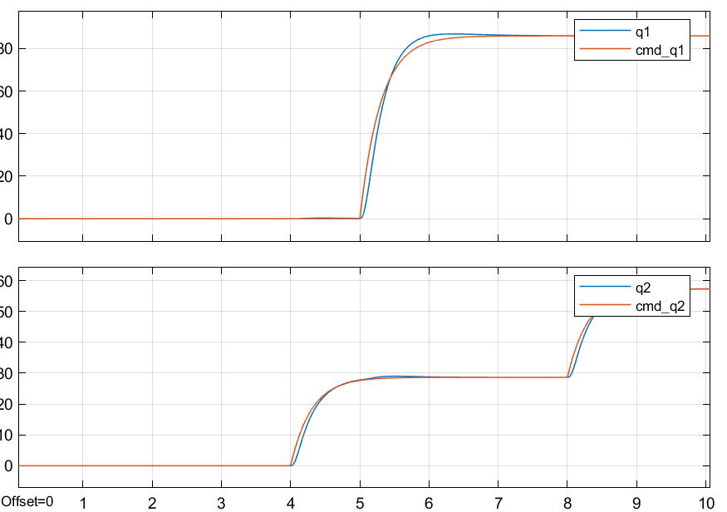

Figure 31: Inverse dynamics control ideal system step response - joint position

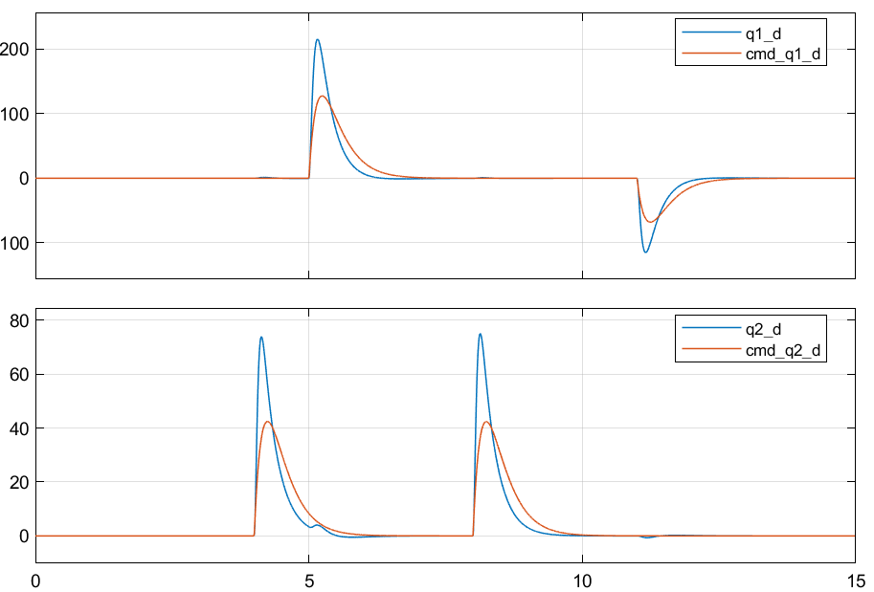

Figure 32: Inverse dynamics control ideal system step response - joint velocity

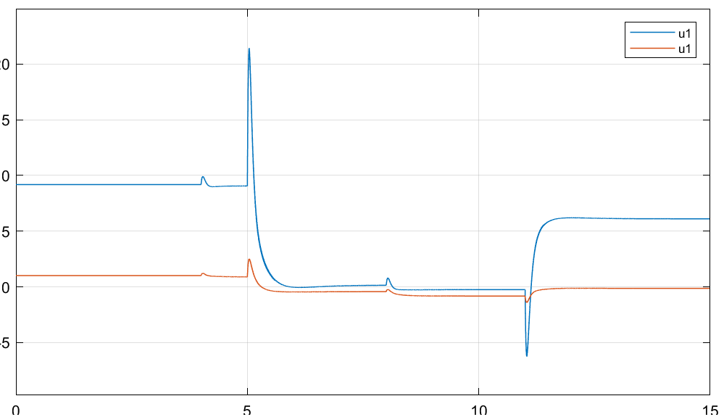

Figure 33: Inverse dynamics control ideal system step response - joint input torque

### Sine wave response

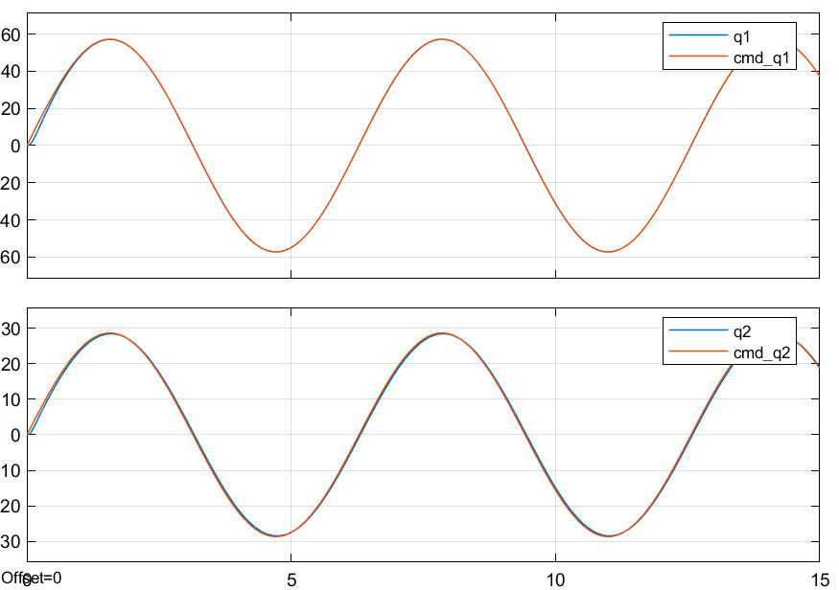

Figure 34: Inverse dynamics control ideal system sine wave response - joint position

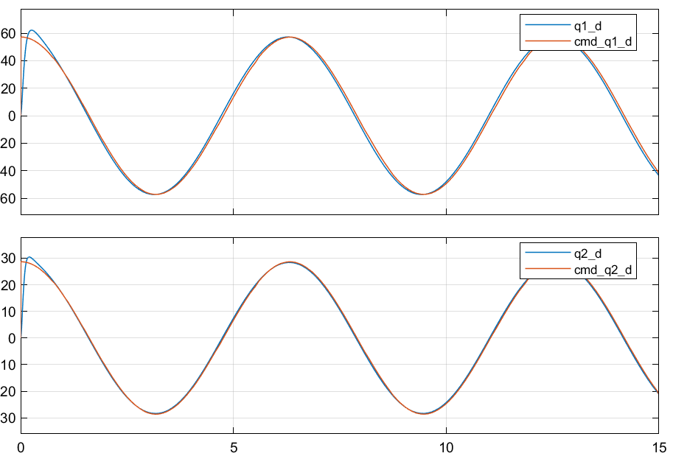

Figure 35: Inverse dynamics control ideal system sine wave response - joint velocity

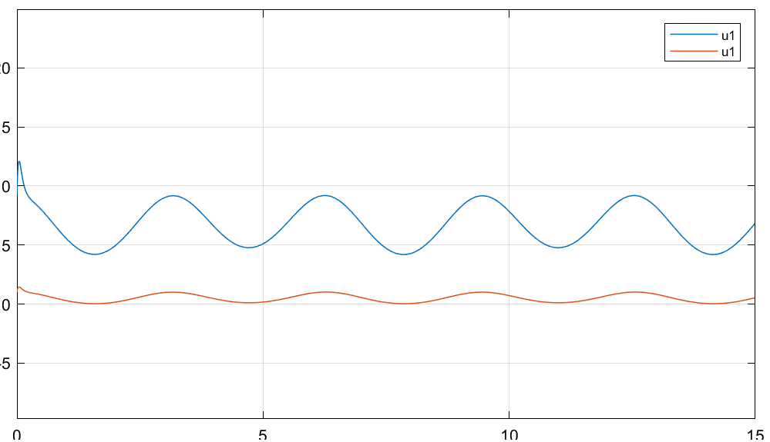

Figure 36: Inverse dynamics control ideal system sine wave response - joint input torque

### Observations

* Steady-state converges to zero and tracking error is much better than Gravity+PD control
* Huge improvements compared to PD-only control and slight improvement compared to gravity+PD control
* Increasing PD gains will result in fast settling time and zero steady-state errors but will introduce high-frequency oscillations in commanded torques.

# Simulation results (realistic) – No parameter deviation

## PD Joint control

Table 8: PD gains – realistic system

|  |  |  |  |
| --- | --- | --- | --- |
| Parameter | Value | Parameter | Value |
|  | 30 |  | 7 |
|  | 2.5 |  | 0.5 |

### Step response

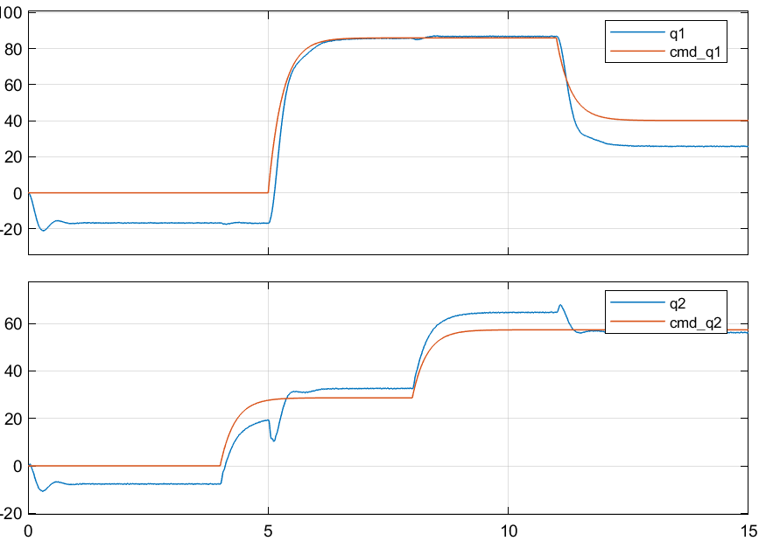

Figure 37: PD control ideal system step response - joint position

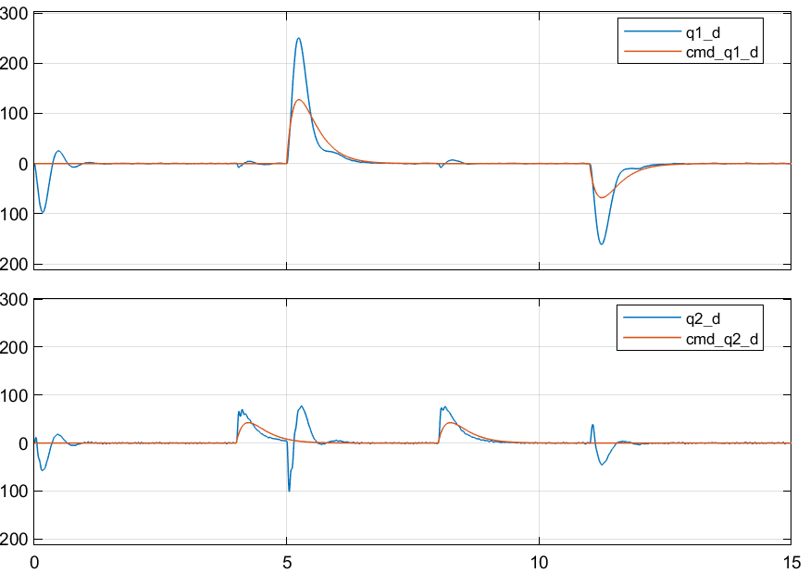

Figure 38: PD control realistic system step response - joint velocity

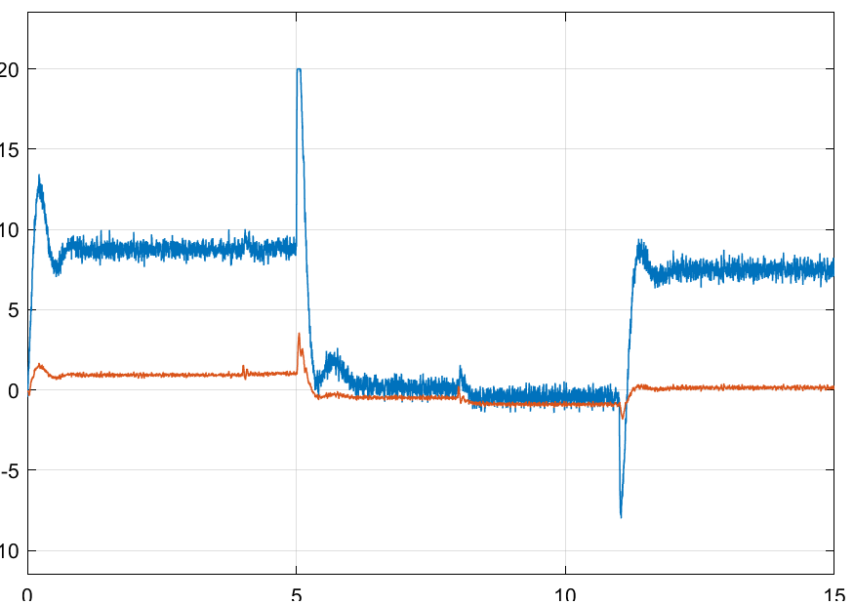

Figure 39: PD control realistic system step response - joint input torque

### Sine wave response

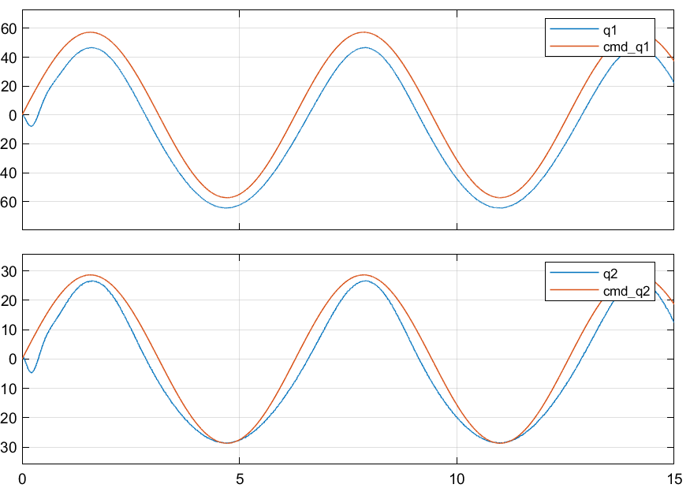

Figure 40: PD control realistic system sine wave response - joint position

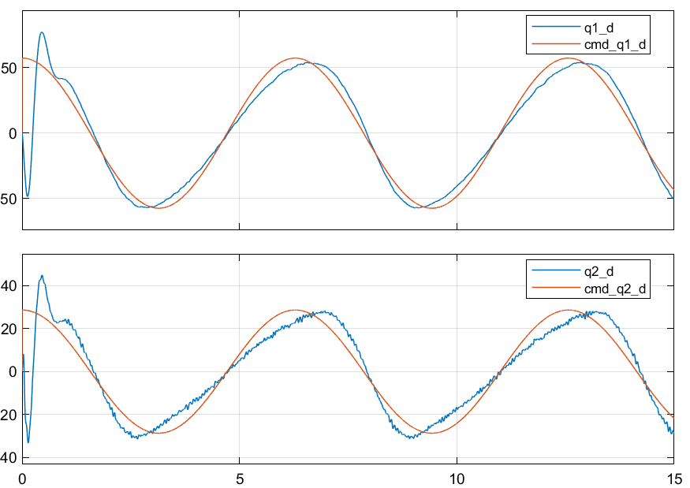

Figure 41: PD control realistic system sine wave response - joint velocity

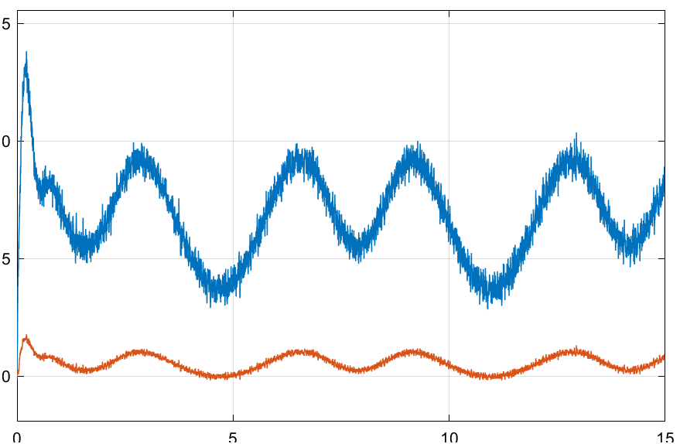

Figure 42: PD control realistic system sine wave response - joint input torque

### Observations

* Similar to ideal case in step response
* Spikes in velocity are smaller due to torque being limited
* Fluctuations in commanded torque due to measurements noise

## PID Joint control

Table 9: PID gains – realistic system

|  |  |  |  |
| --- | --- | --- | --- |
| Parameter | Value | Parameter | Value |
|  | 30 |  | 7 |
|  | 2.5 |  | 0.5 |
|  | 20 |  | 15 |

### Step response

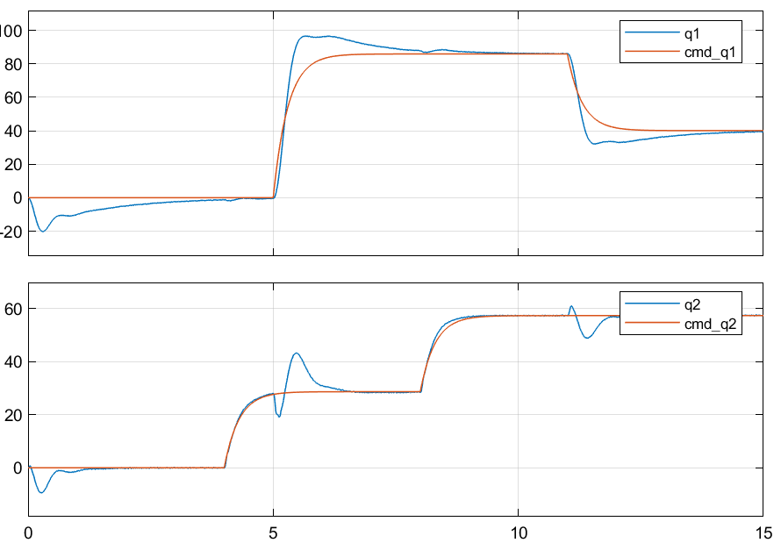

Figure 43: PID control ideal system step response - joint position

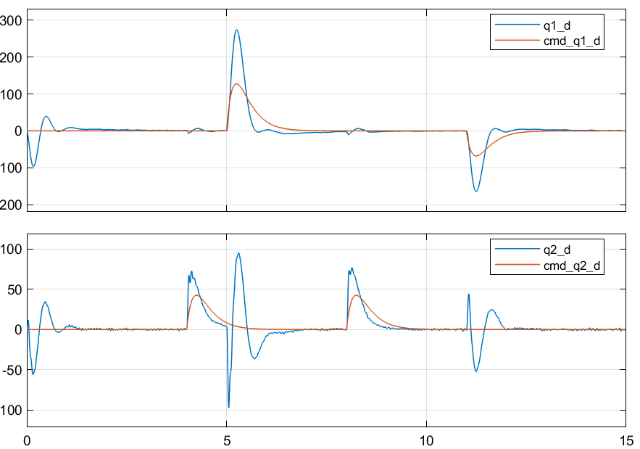

Figure 44: PID control realistic system step response - joint velocity

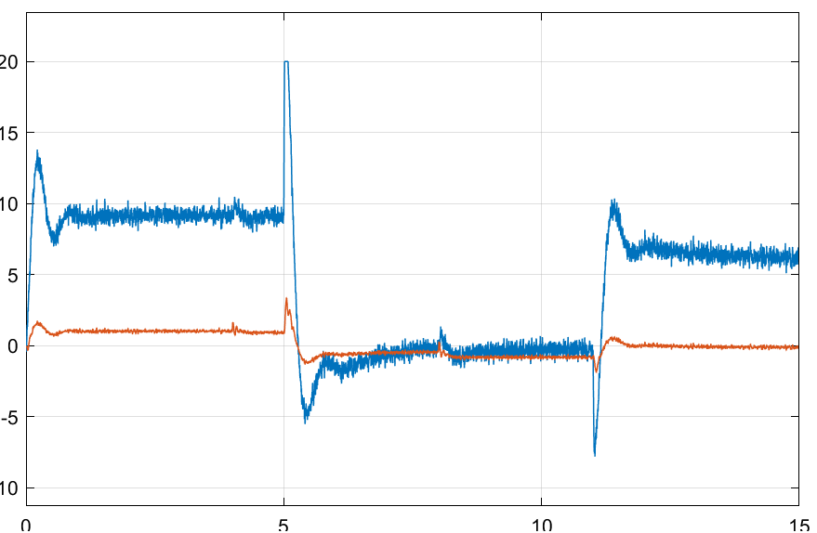

Figure 45: PID control realistic system step response - joint input torque

### Sine wave response

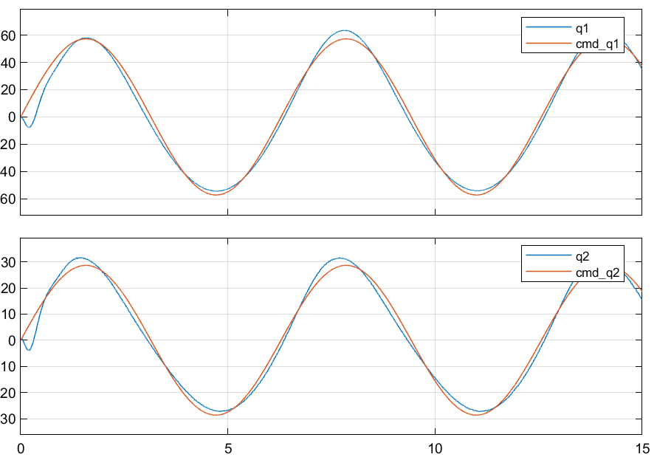

Figure 46: PID control realistic system sine wave response - joint position

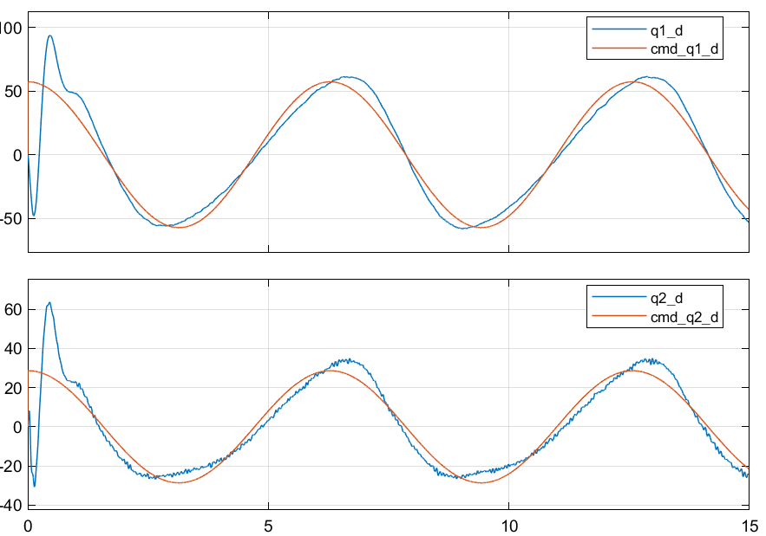

Figure 47: PID control realistic system sine wave response - joint velocity

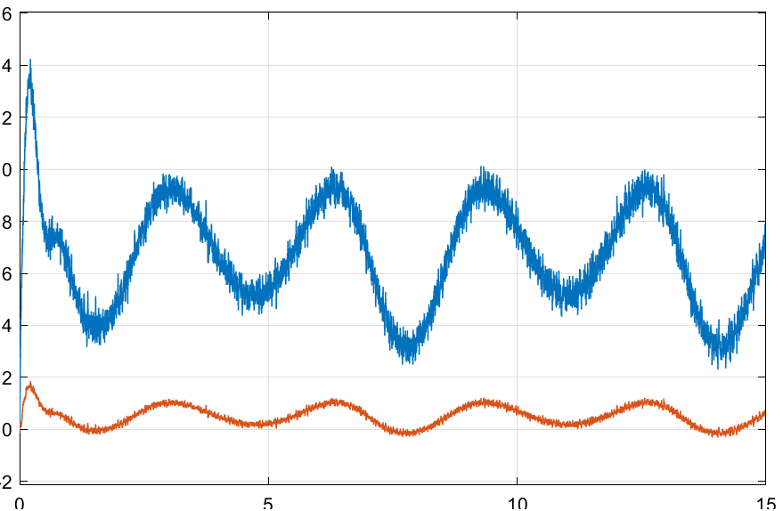

Figure 48: PID control realistic system sine wave response - joint input torque

### Observations

* Steady-state goes to zero if given enough time
* Tracking error is still not zero due to response lag
* Performance is worse than ideal case in terms of overshoot and settling time
* Has small-magnitude ripples in commanded torque but no high-magnitude high frequency damped oscillations similar to that of ideal case
* Torque is bounded unlike ideal case and huge spikes in commanded torque happen
* Gains can be further tuned and if increased a lot, tracking and steady-state errors will be smaller but it will result in huge oscillations in commanded torques.

## Pole Placement Control

Table 10: Pole values and feedback gain- realistic case

|  |  |
| --- | --- |
| Parameter | Value |
| poles | [-25, -24, -23, -5.8] |
|  |  |

### Step response

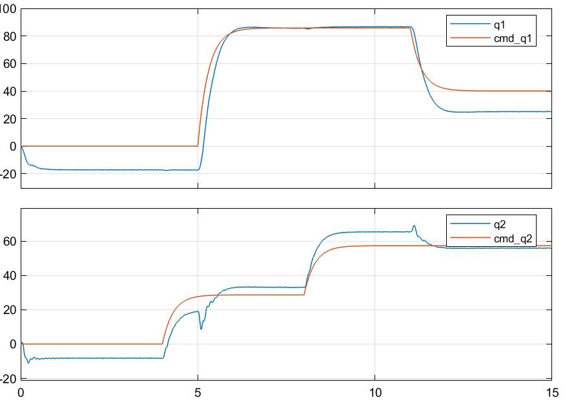

Figure 49: Pole placement control realistic system step response - joint position

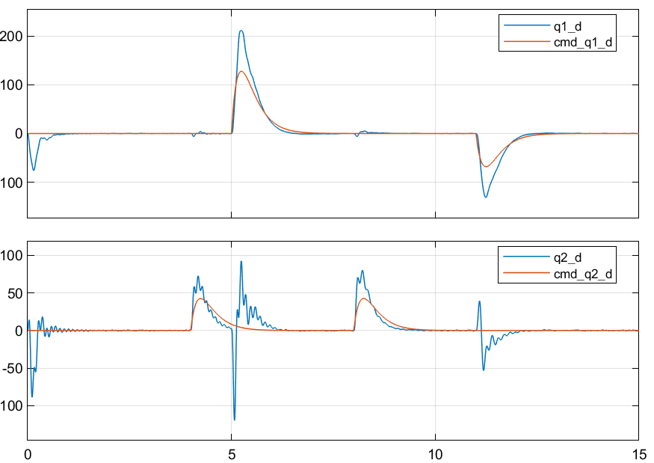

Figure 50: Pole placement control realistic system step response - joint velocity

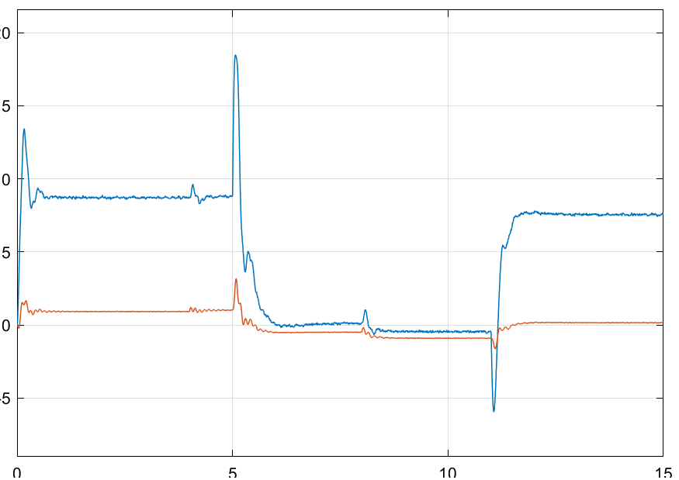

Figure 51: Pole placement control realistic system step response - joint input torque

### Sine wave response

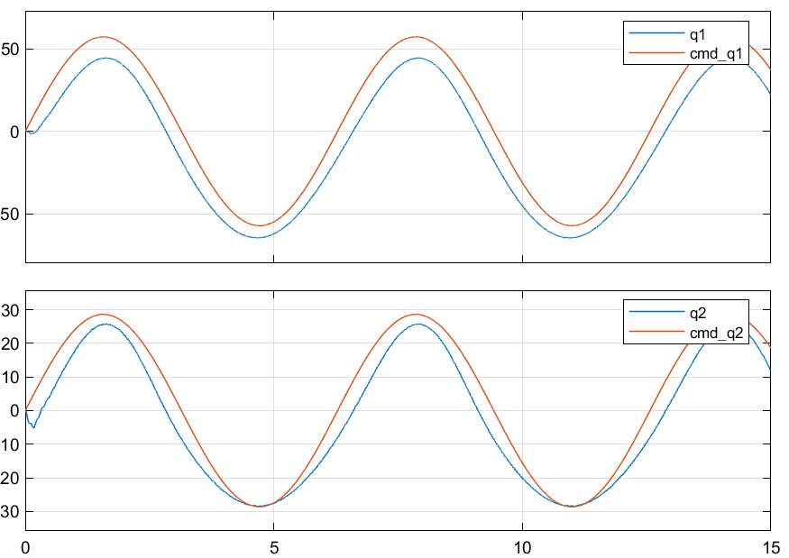

Figure 52: Pole placement control realistic system sine wave response - joint position

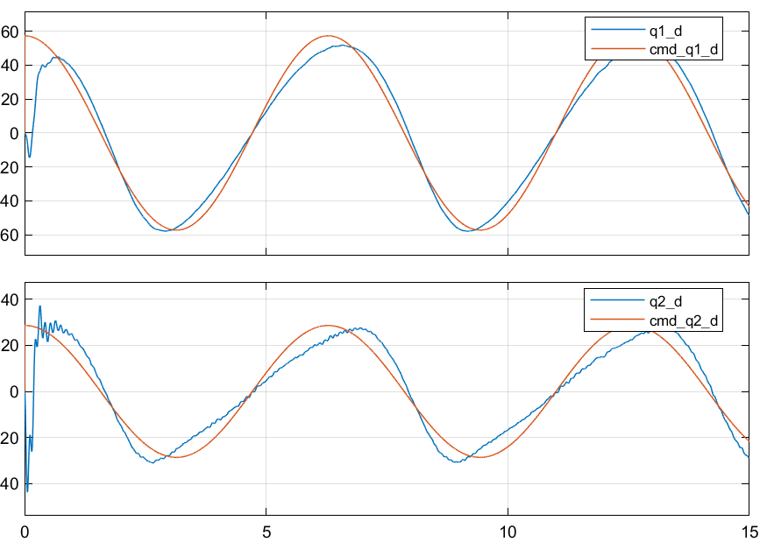

Figure 53: Pole placement control realistic system sine wave response - joint velocity

### Observations

* Nonzero Steady-state and tracking error

## Pole Placement Control with feedforward disturbance terms

### Step response

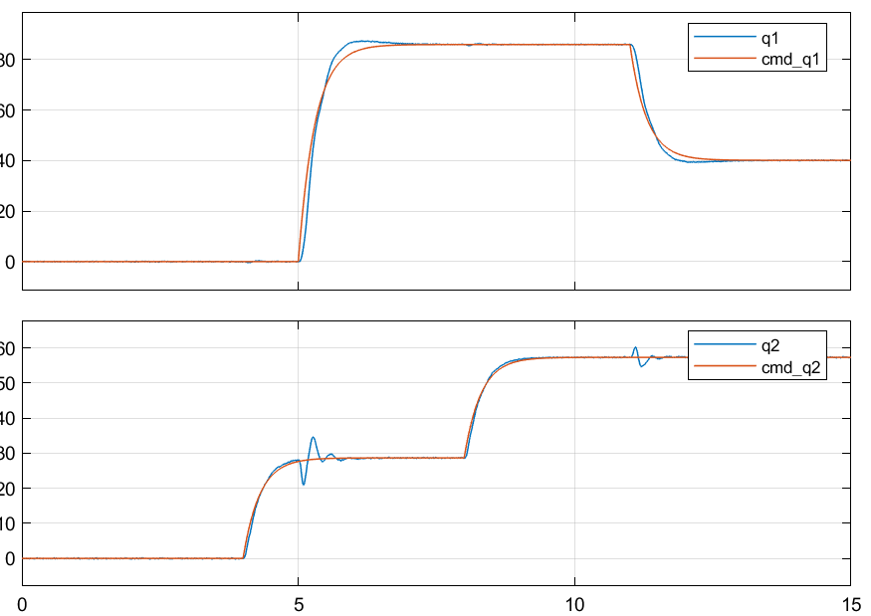

Figure 54: Pole placement+D control realistic system step response - joint position

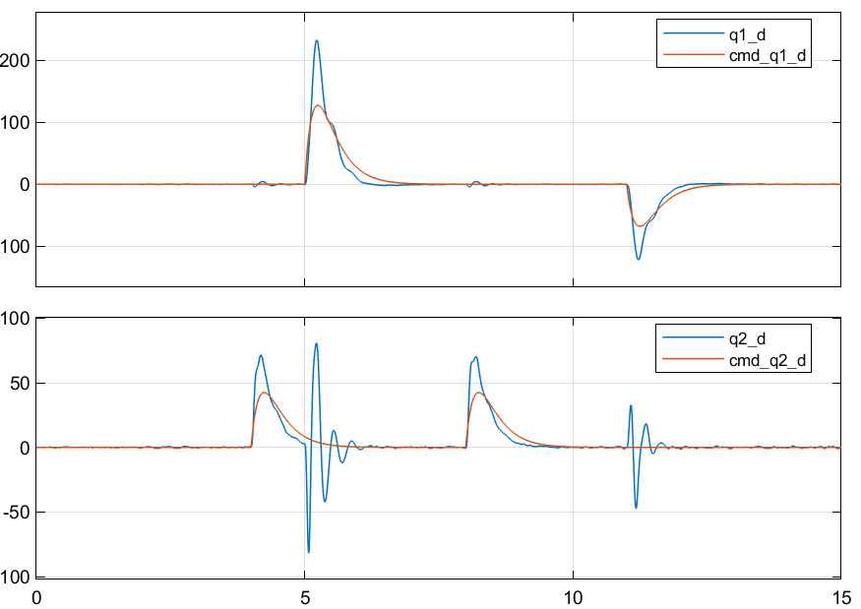

Figure 55: Pole placement+D control realistic system step response - joint velocity

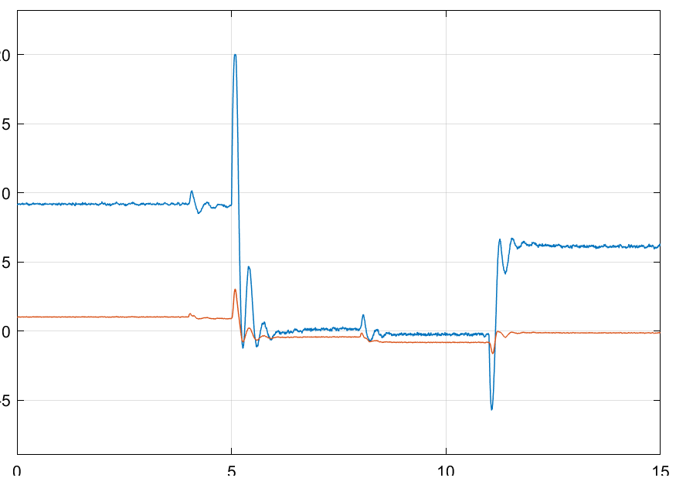

Figure 56: Pole placement+D control realistic system step response - joint input torque

### Sine wave response

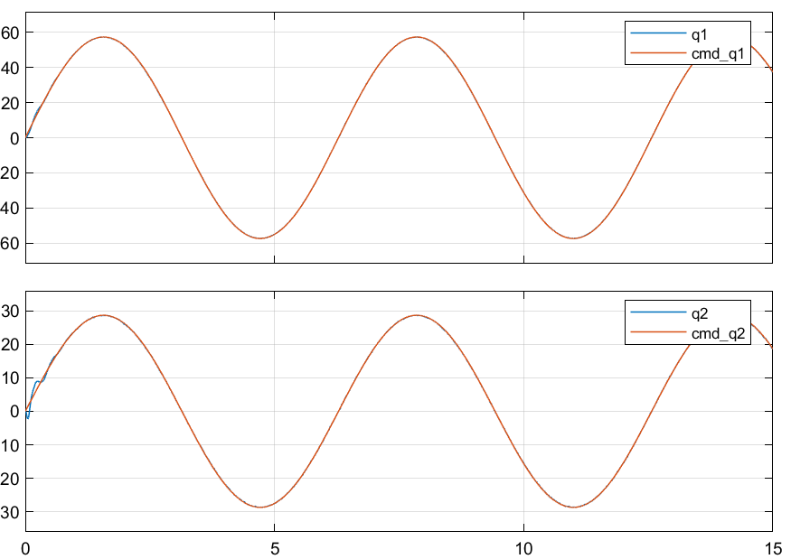

Figure 57: Pole placement+D control realistic system sine wave response - joint position

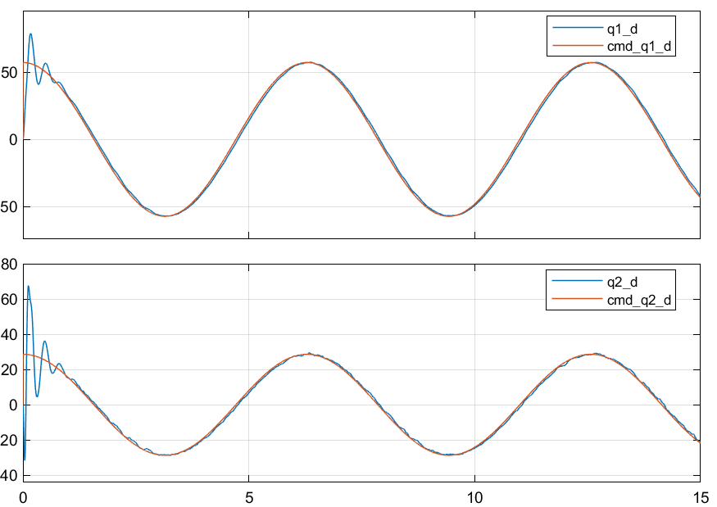

Figure 58: Pole placement+D control realistic system sine wave response - joint velocity

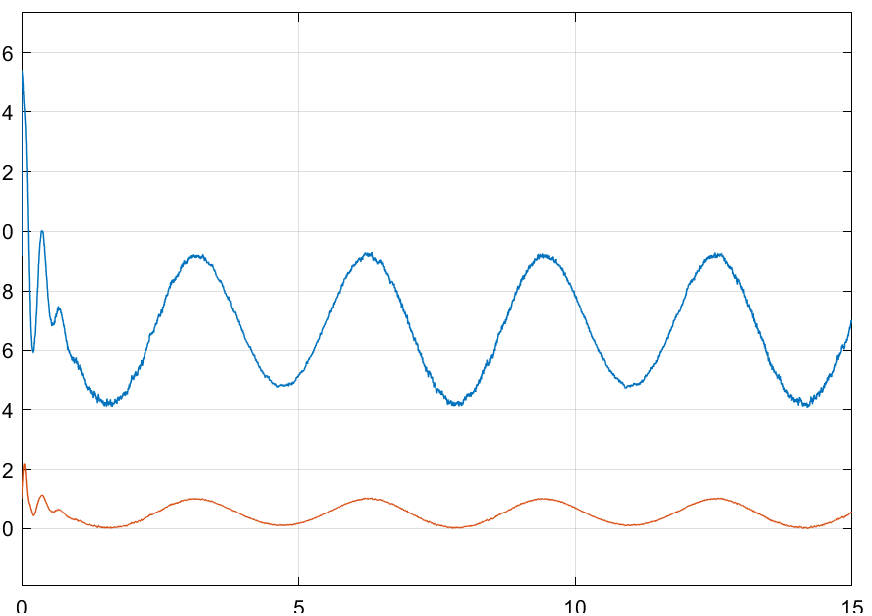

Figure 59: Pole placement+D control realistic system sine wave response - joint input torque

### Observations

* Zero Steady-state and tracking errors.
* Some overshoot in position and big overshoot in velocity step response
* Tracking the sine wave position and velocity is quite good

## PD+Gravity compensation Joint control

Table 11: PD gains for Gravity+PD control – realistic system

|  |  |  |  |
| --- | --- | --- | --- |
| Parameter | Value | Parameter | Value |
|  | 15 |  | 3.5 |
|  | 2.5 |  | 0.5 |

### Step response

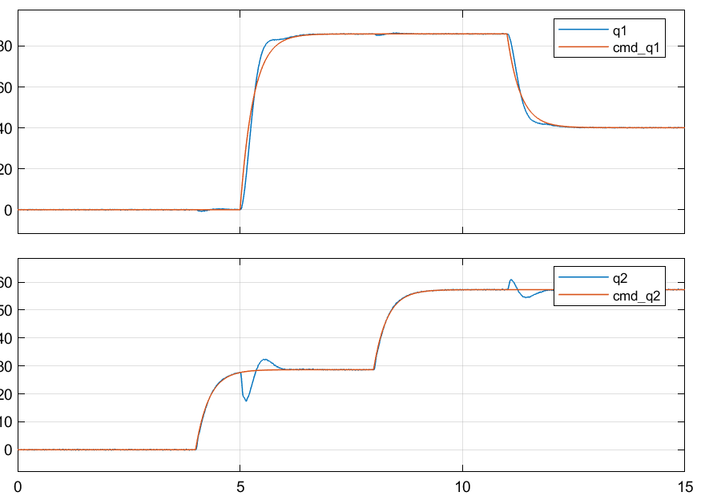

Figure 60: GRAVITY+PD control realistic system step response - joint position

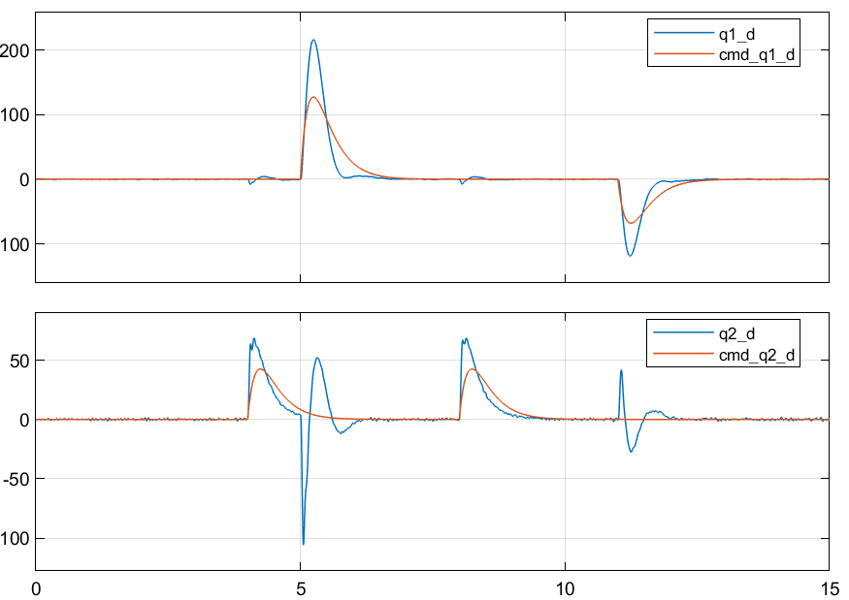

Figure 61: GRAVITY+PD control realistic system step response - joint velocity

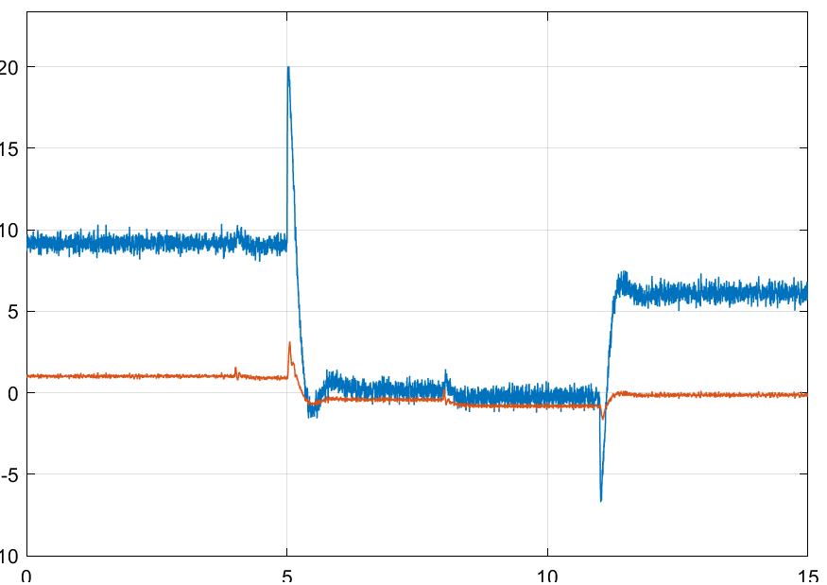

Figure 62: GRAVITY+PD control realistic system step response - joint input torque

### Sine wave response

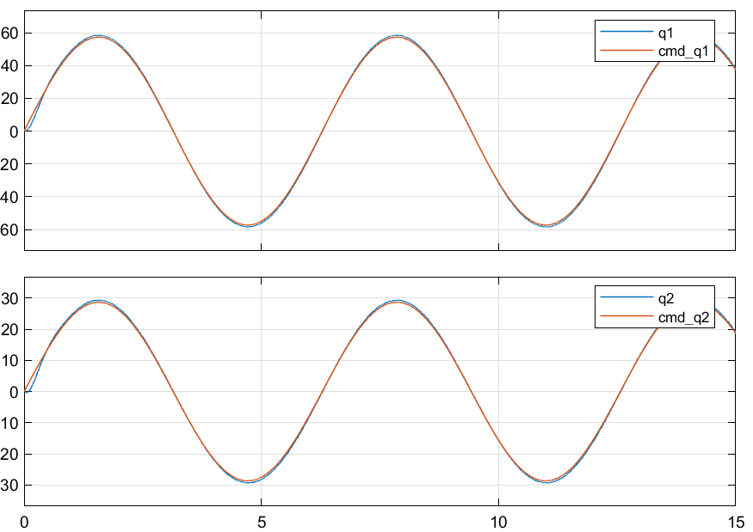

Figure 63: GRAVITY+PD control realistic system sine wave response - joint position

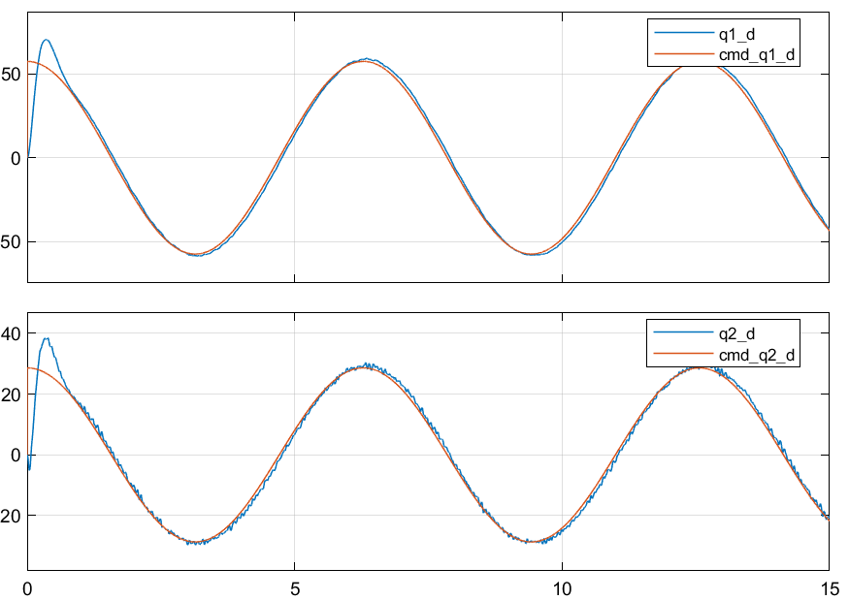

Figure 64: GRAVITY+PD control realistic system sine wave response - joint velocity

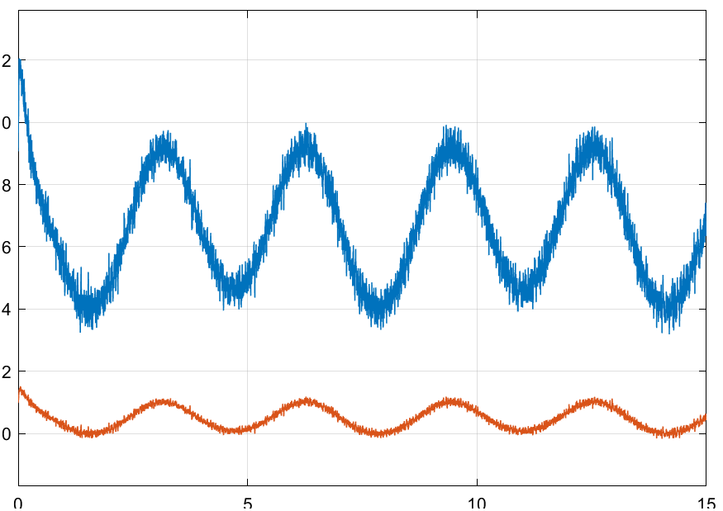

Figure 65: GRAVITY+PD control realistic system sine wave response - joint input torque

### Observations

* Steady-state converges to zero and tracking error is within 1 degree
* Similar to ideal case response
* Increasing PD gains will result in faster settling time and zero steady-state errors but will introduce high-frequency oscillations in commanded torques.

## Inverse dynamics control

Table 12: PD gains – Inverse control – Realistic system

|  |  |  |  |
| --- | --- | --- | --- |
| Parameter | Value | Parameter | Value |
|  | 25 |  | 50 |
|  | 12 |  | 15 |

### Step response

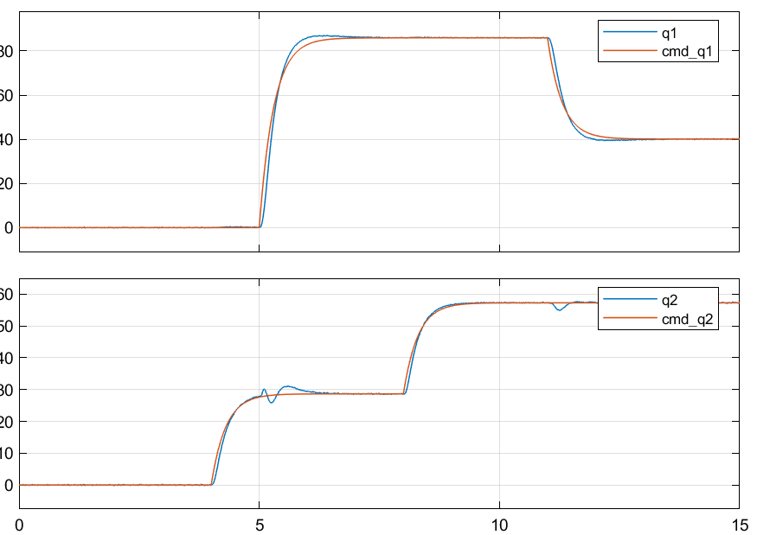

Figure 66: Inverse dynamics control realistic system step response - joint position

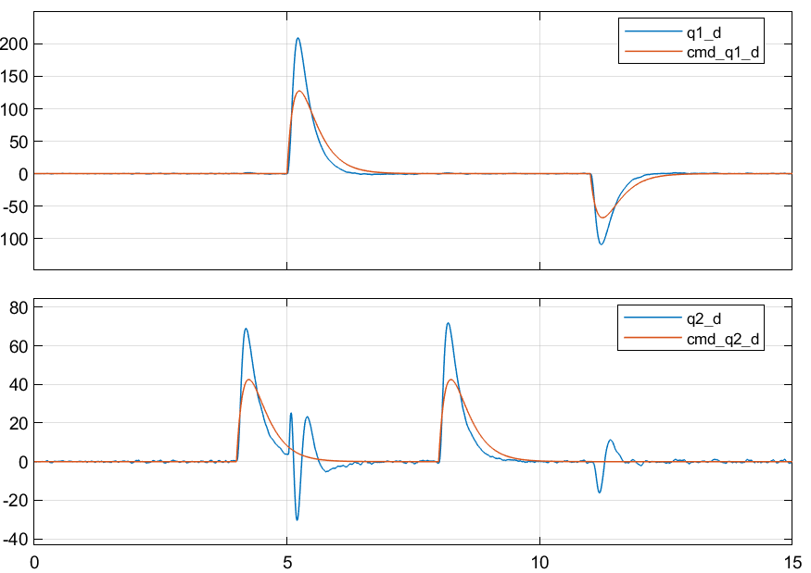

Figure 67: Inverse dynamics control realistic system step response - joint velocity

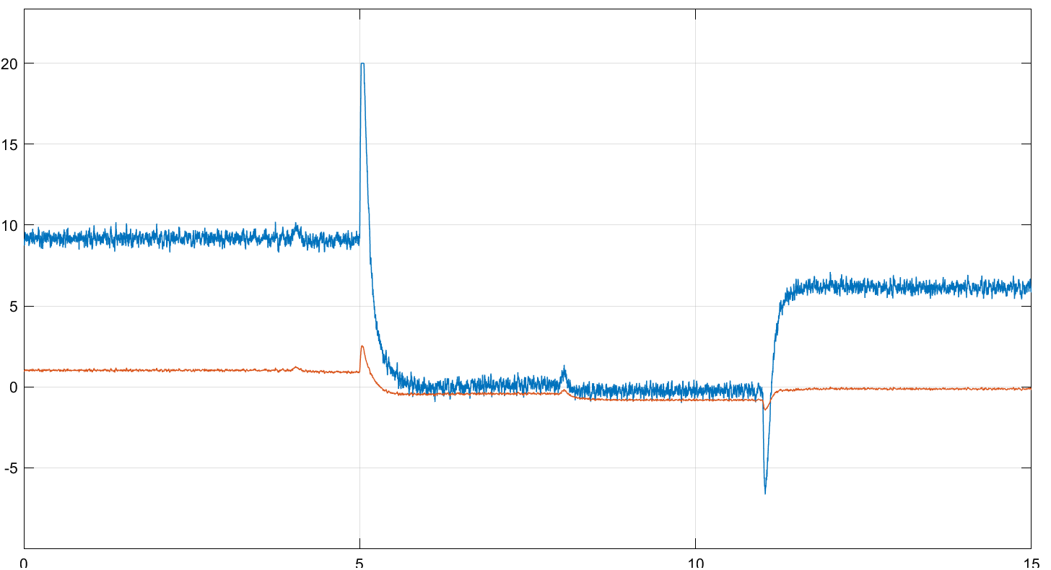

Figure 68: Inverse dynamics control realistic system step response - joint input torque

### Sine wave response

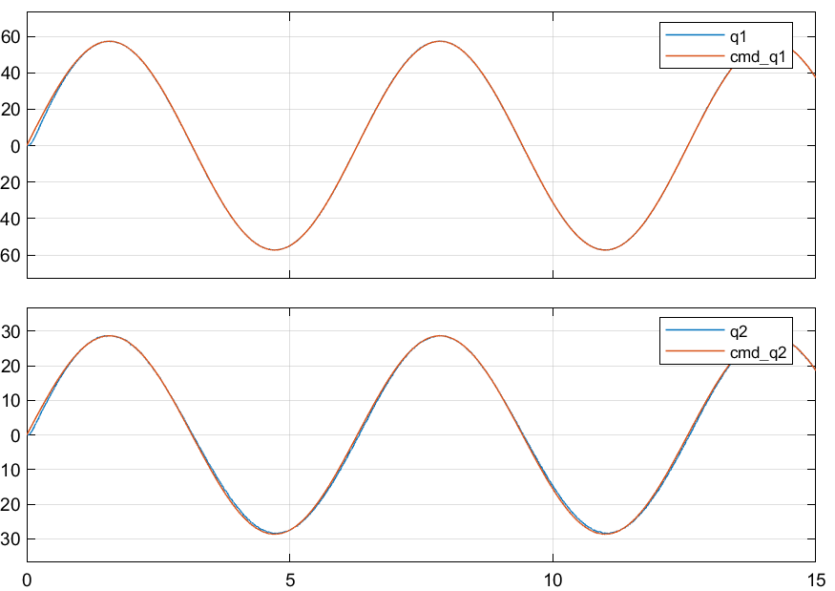

Figure 69: Inverse dynamics control realistic system sine wave response - joint position

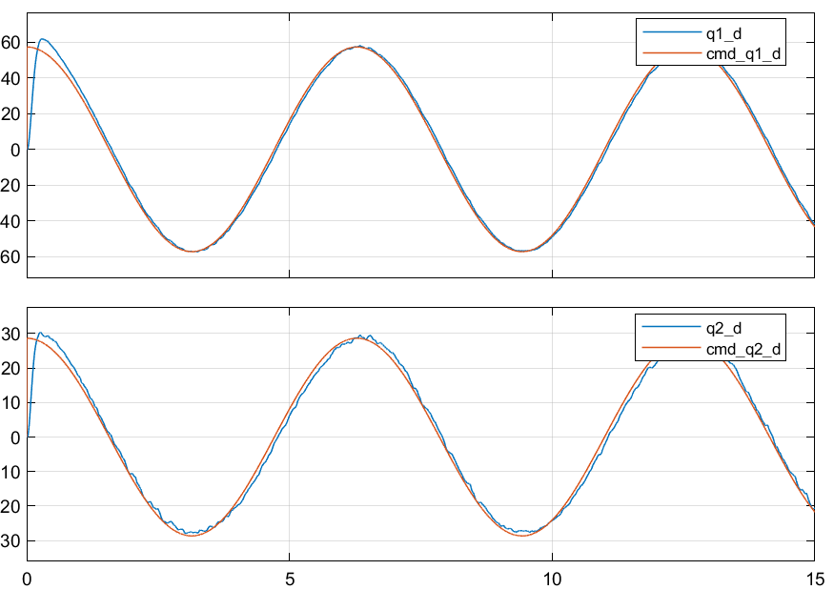

Figure 70: Inverse dynamics control realistic system sine wave response - joint velocity

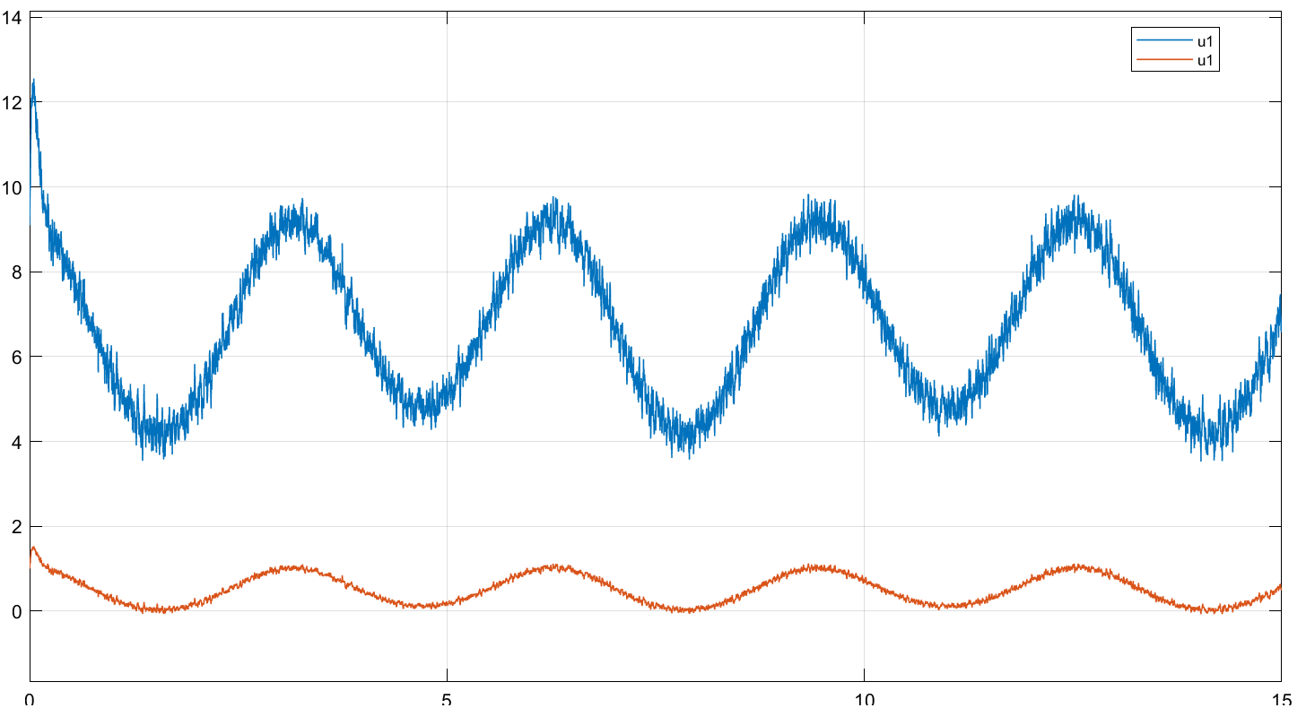

Figure 71: Inverse dynamics control realistic system sine wave response - joint input torque

### Observations

* Steady-state converges to zero and tracking error is better than Gravity+PD control
* Similar to ideal case with some ripples in velocity response due to measurement noise.
* Increasing PD gains will result in fast settling time and zero steady-state errors but will introduce high-frequency oscillations in commanded torques.

## Robust control

Table 13: PD gains for robust control – Realistic system

|  |  |  |  |
| --- | --- | --- | --- |
| Parameter | Value | Parameter | Value |
|  | 25 |  | 45 |
|  | 7 |  | 35 |
|  | 0.1 |  | 1 |
|  |  |  |  |

### Step response

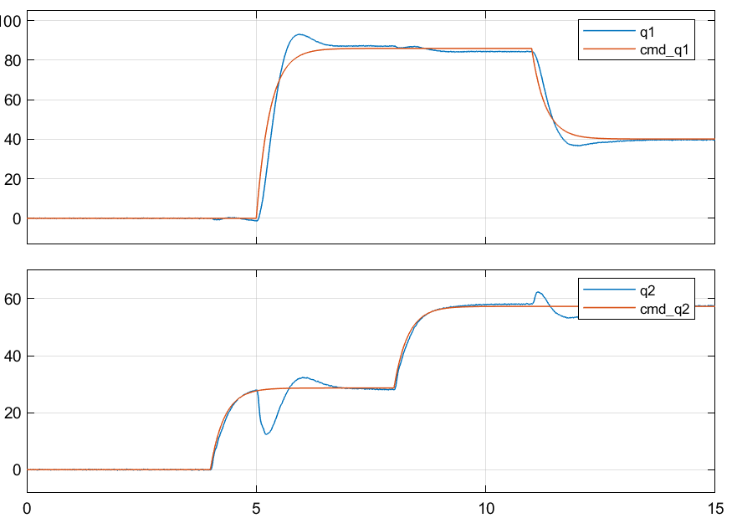

Figure 72: Robust control realistic system step response - joint position

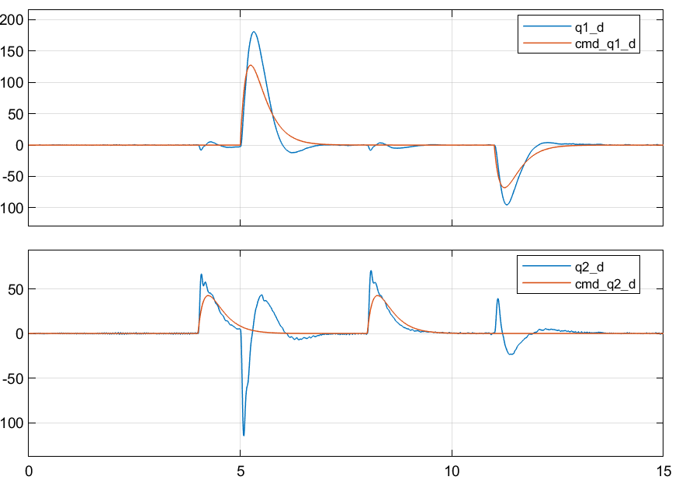

Figure 73: Robust control realistic system step response - joint velocity

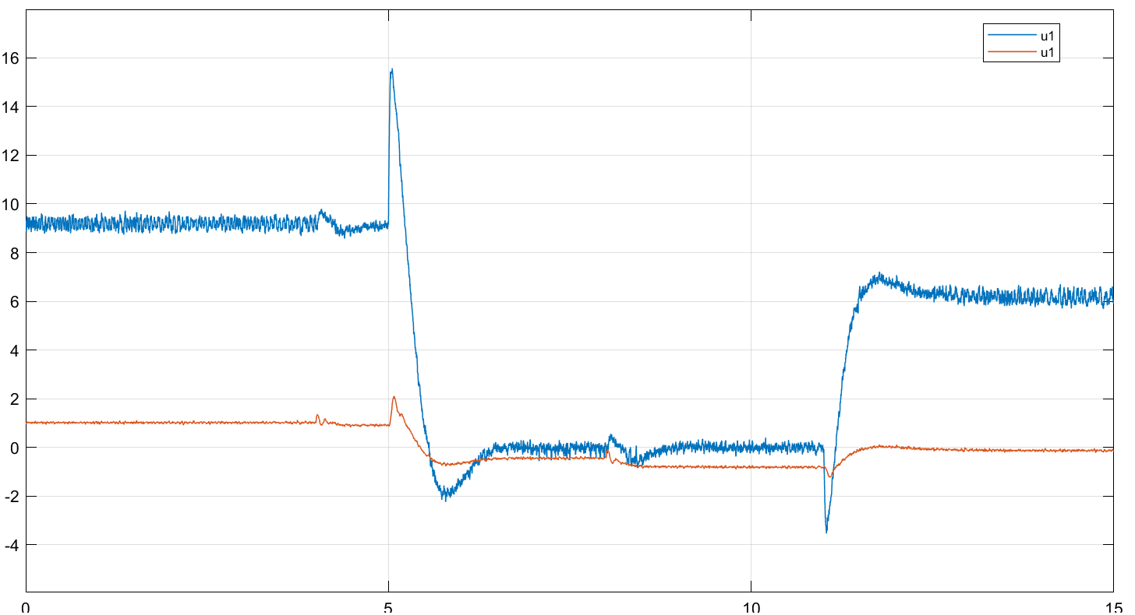

Figure 74: Robust control realistic system step response - joint input torque

### Sine wave response

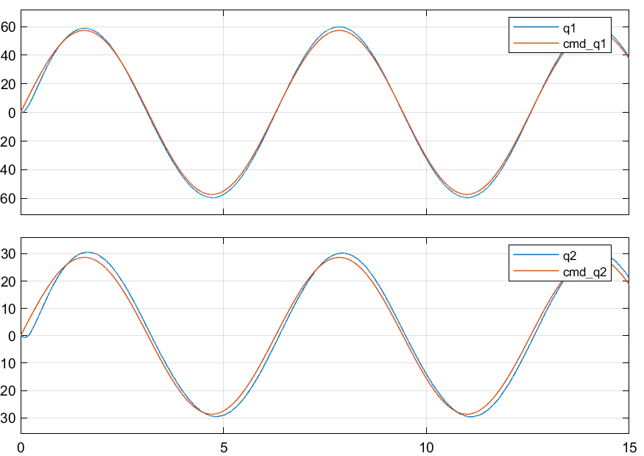

Figure 75: Robust control realistic system sine wave response - joint position

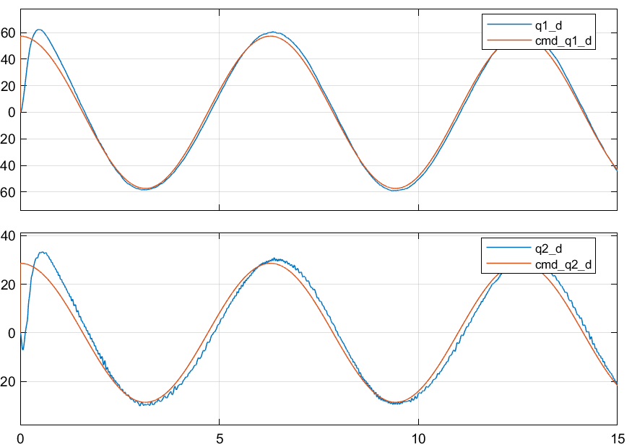

Figure 76: Robust control realistic system sine wave response - joint velocity

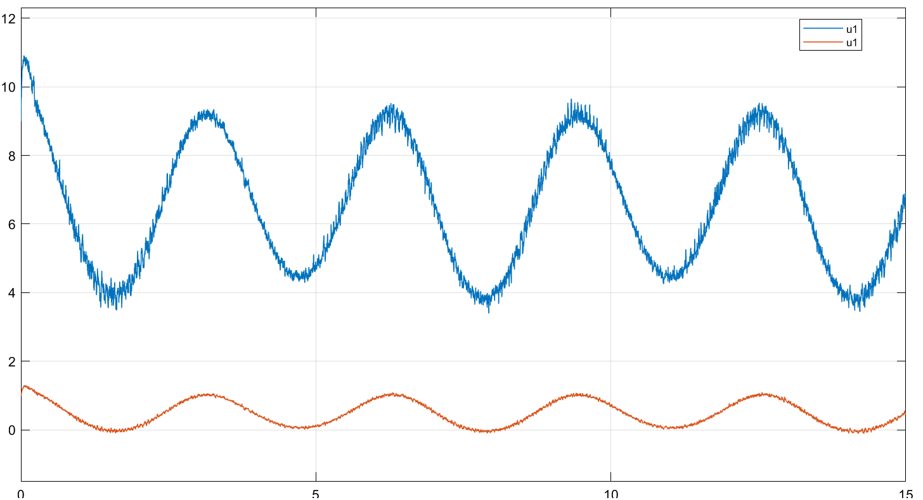

Figure 77: Robust control realistic system sine wave response - joint input torque

### Observations

* Worse in performance than inverse dynamics control and gravity+PD control

# Simulation results (realistic) – with parameter deviation

## Pole Placement Control with feedforward disturbance terms

### Step response

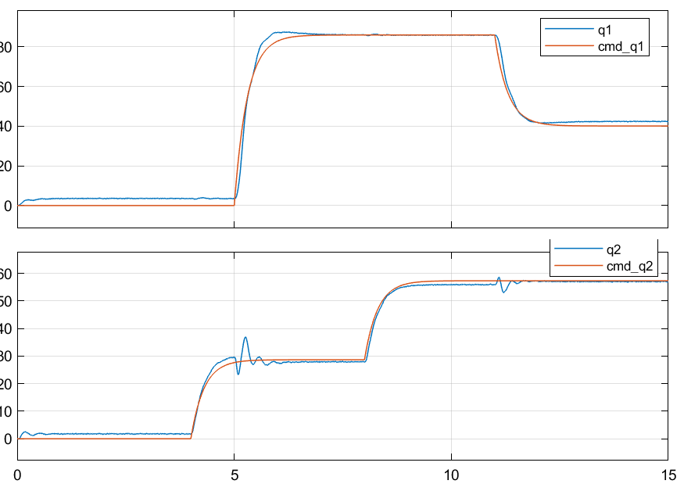

Figure 78: Pole placement+D control realistic system step response - joint position – with parameter deviation

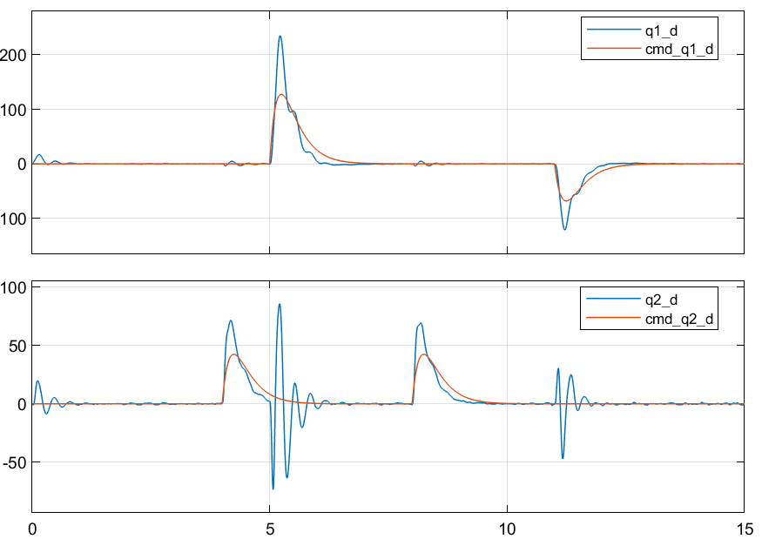

Figure 79: Pole placement+D control realistic system step response - joint velocity – with parameter deviation

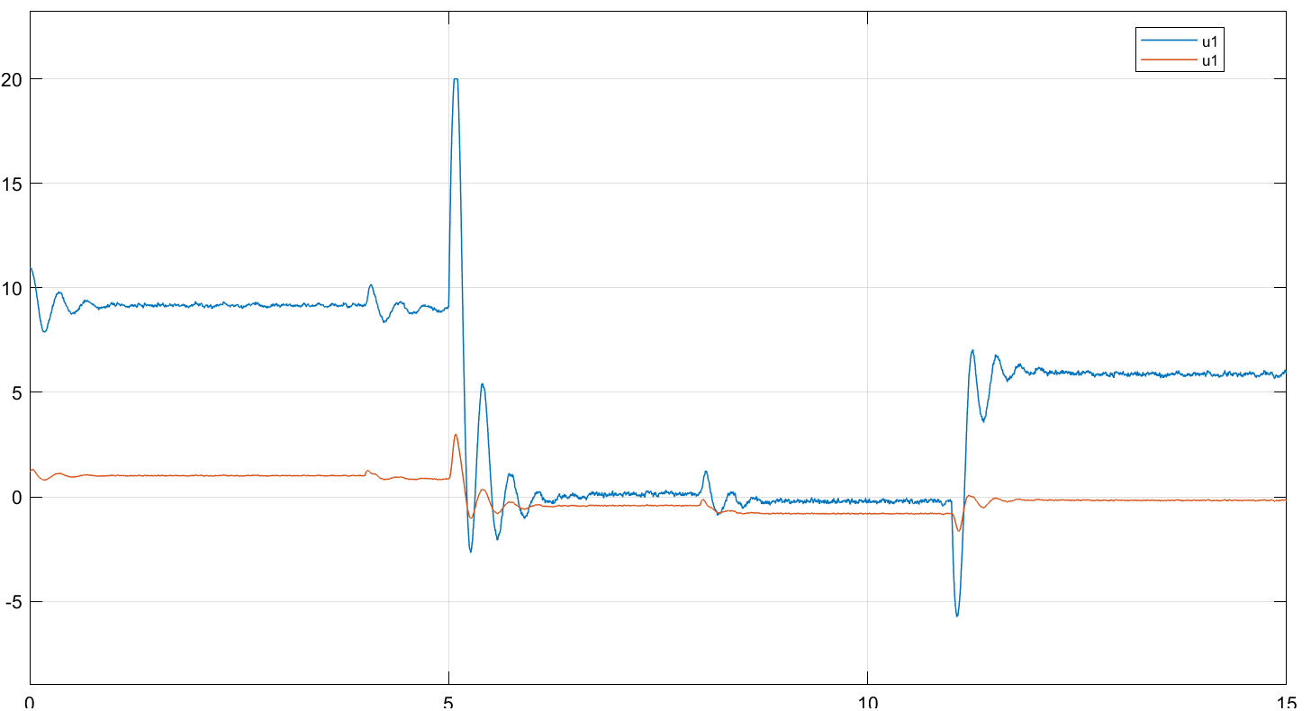

Figure 80: Pole placement+D control realistic system step response - joint input torque – with parameter deviation

### Sine wave response

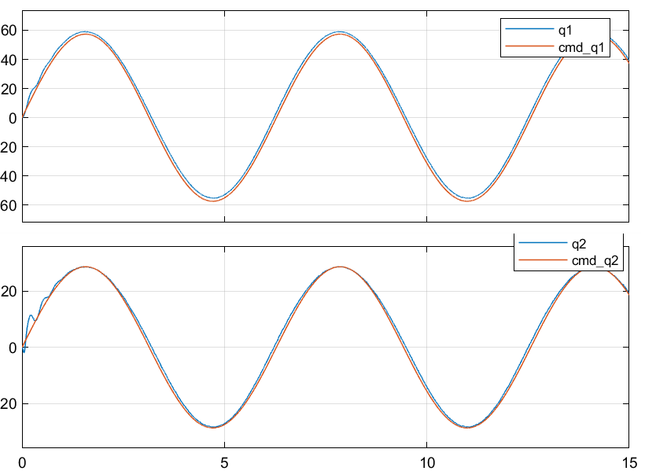

Figure 81: Pole placement+D control realistic system sine wave response - joint position – with parameter deviation

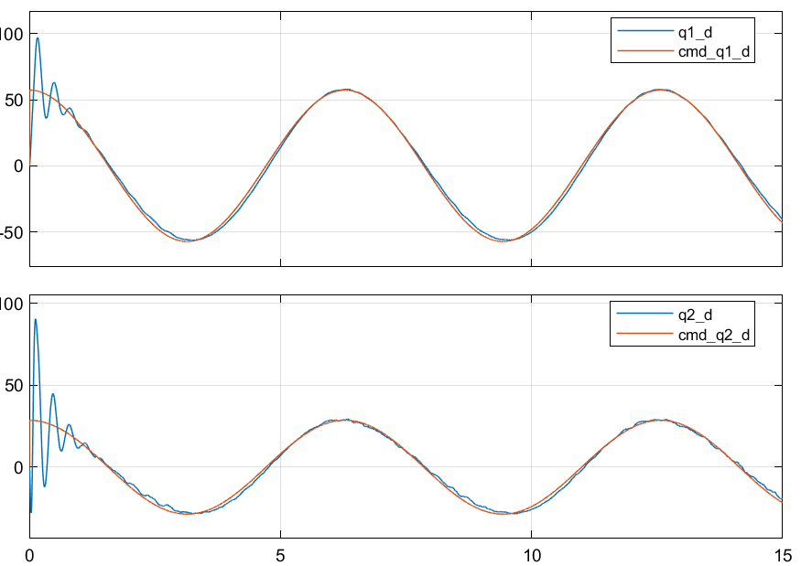

Figure 82: Pole placement+D control realistic system sine wave response - joint velocity – with parameter deviation

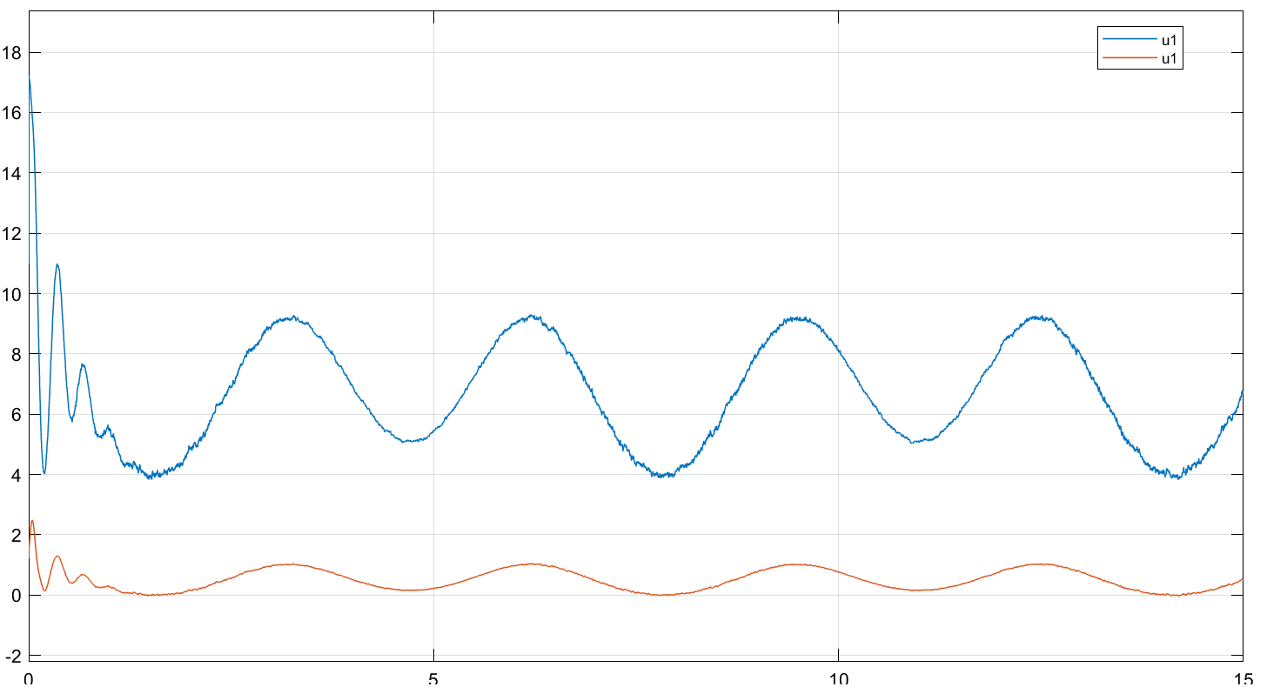

Figure 83: Pole placement+D control realistic system sine wave response - joint input torque – with parameter deviation

### Observations

* Convergence to steady-state takes longer than when there is no parameter deviation
* Overshoots and oscillations are bigger than when there is no parameter deviation
* Tracking error is worse but still acceptable

## PD+Gravity compensation Joint control

### Step response

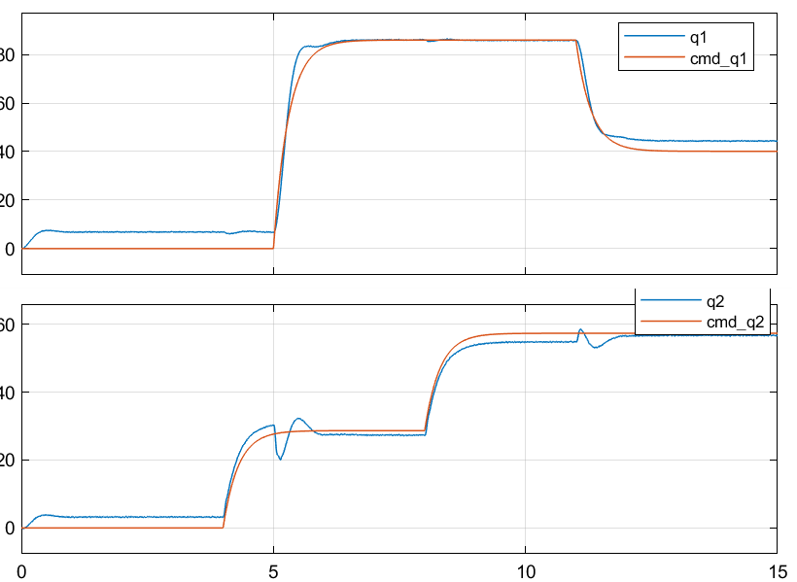

Figure 84: GRAVITY+PD control realistic system step response - joint position – with parameter deviation

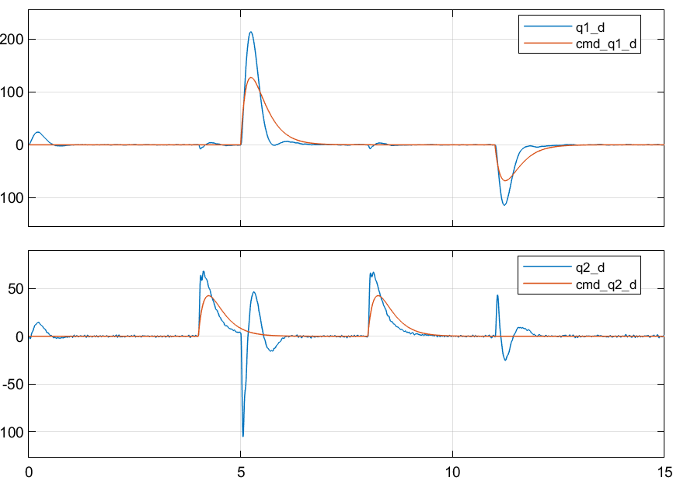

Figure 85: GRAVITY+PD control realistic system step response - joint velocity – with parameter deviation

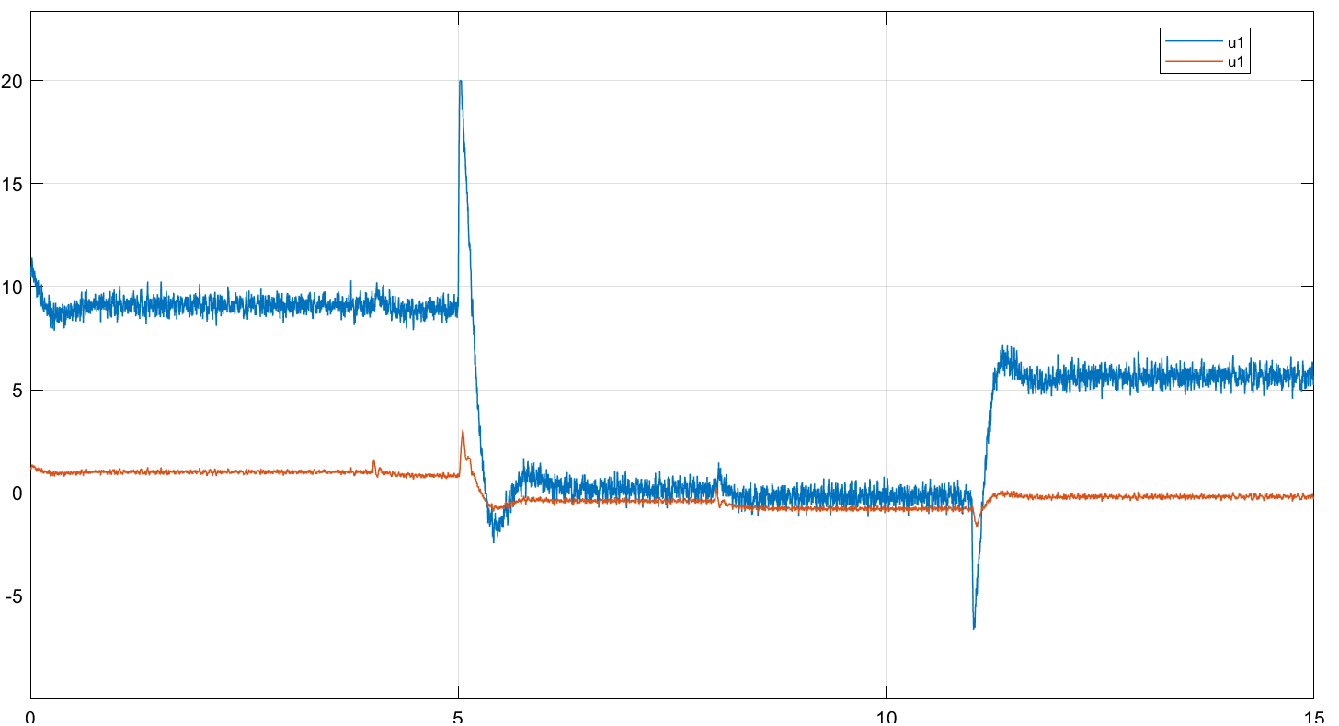

Figure 86: GRAVITY+PD control realistic system step response - joint input torque – with parameter deviation

### Sine wave response

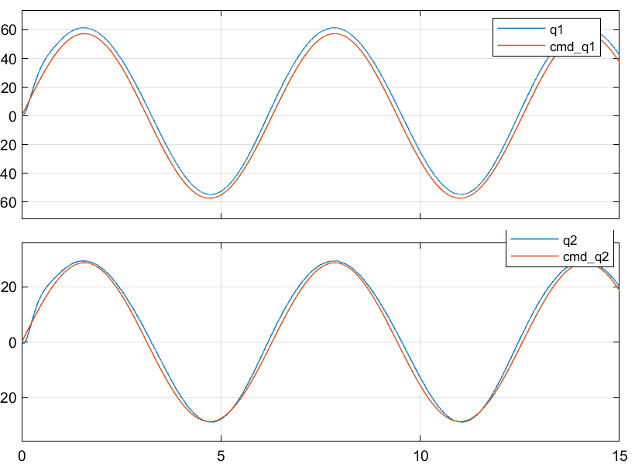

Figure 87: GRAVITY+PD control realistic system sine wave response - joint position – with parameter deviation

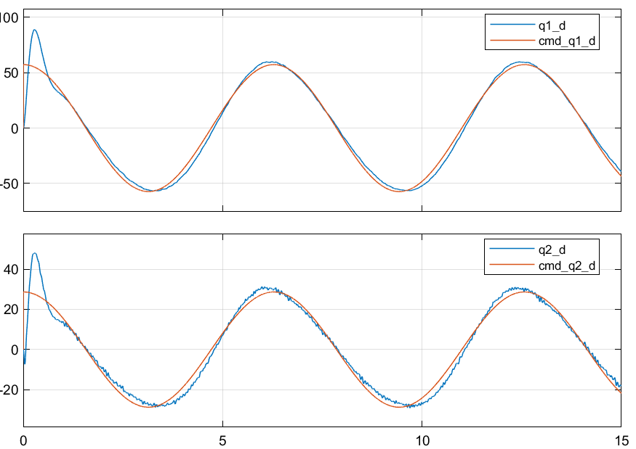

Figure 88: GRAVITY+PD control realistic system sine wave response - joint velocity – with parameter deviation

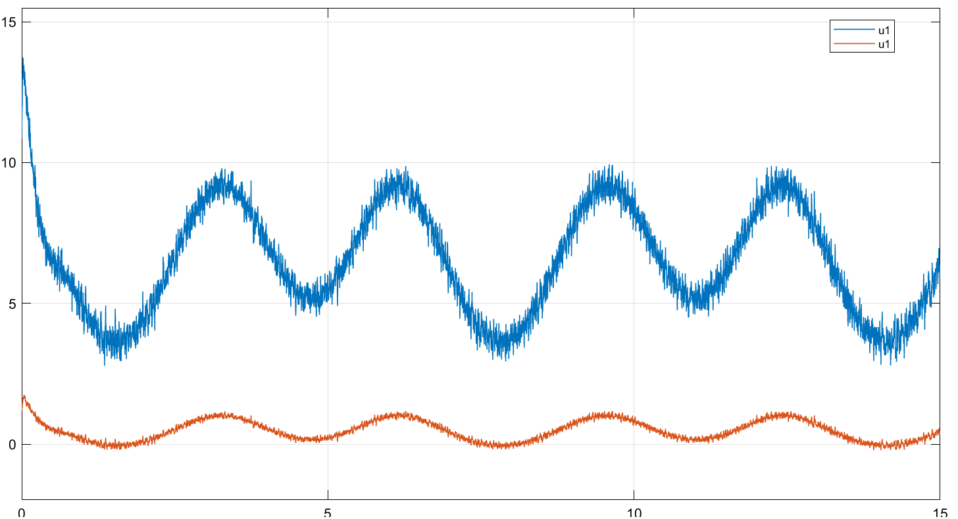

Figure 89: GRAVITY+PD control realistic system sine wave response - joint input torque – with parameter deviation

### Observations

* Bigger Steady-state error and tracking error is worse, within 4 degrees

## Inverse dynamics control

### Step response

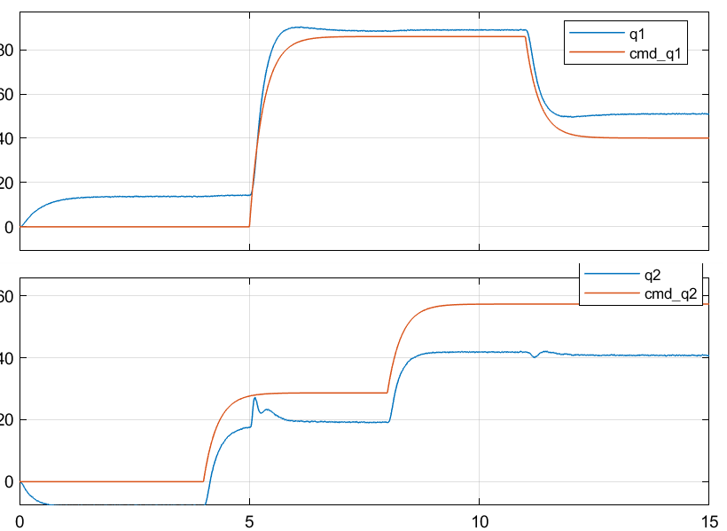

Figure 90: Inverse dynamics control realistic system step response - joint position – with parameter deviation

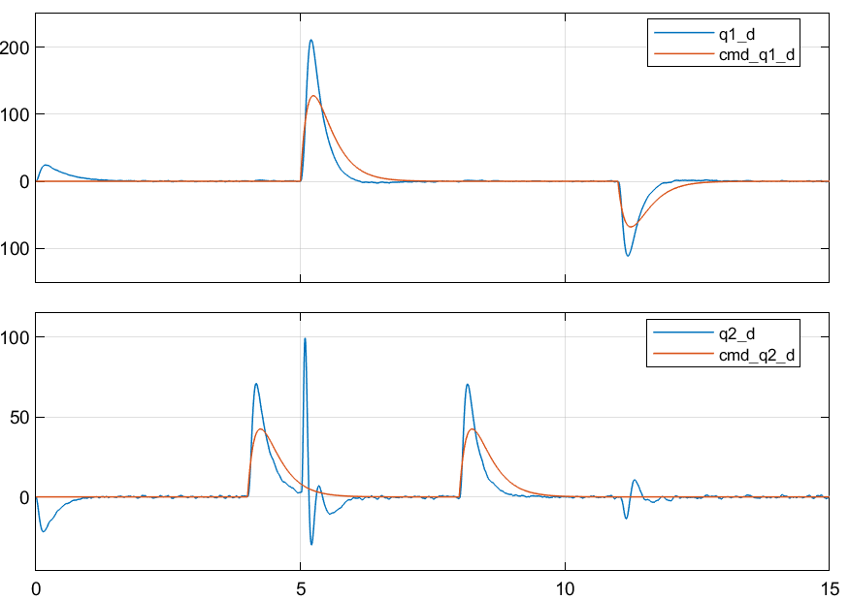

Figure 91: Inverse dynamics control realistic system step response - joint velocity – with parameter deviation

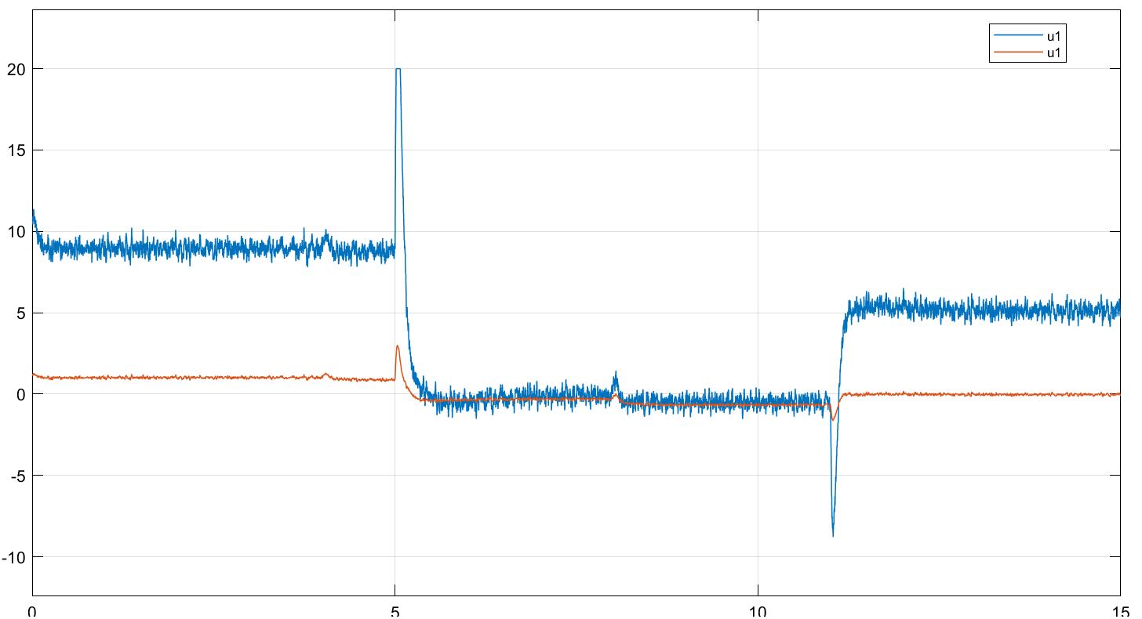

Figure 92: Inverse dynamics control realistic system step response - joint input torque – with parameter deviation

### Sine wave response

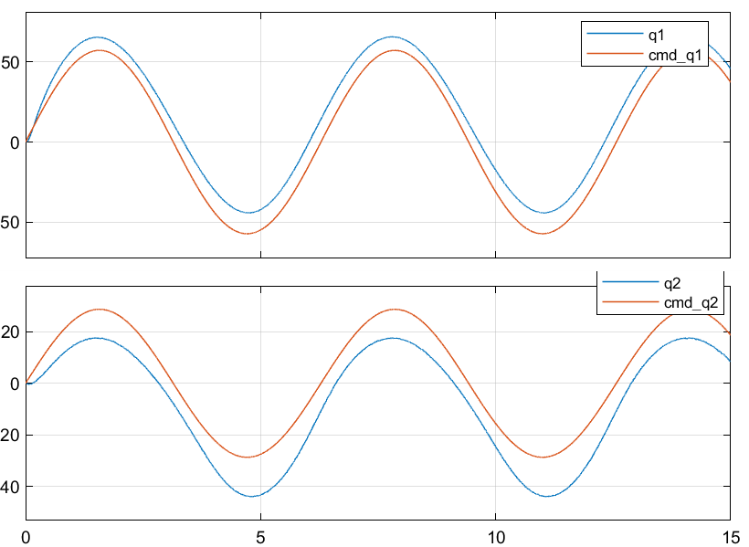

Figure 93: Inverse dynamics control realistic system sine wave response - joint position – with parameter deviation

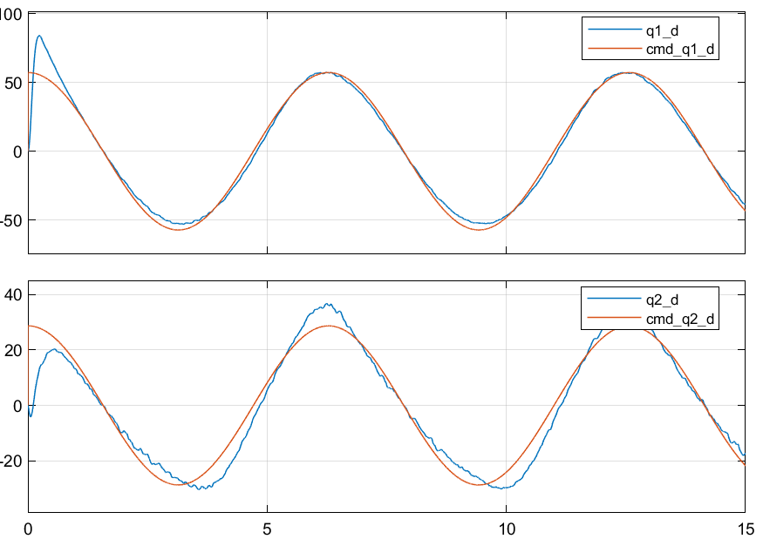

Figure 94: Inverse dynamics control realistic system sine wave response - joint velocity – with parameter deviation

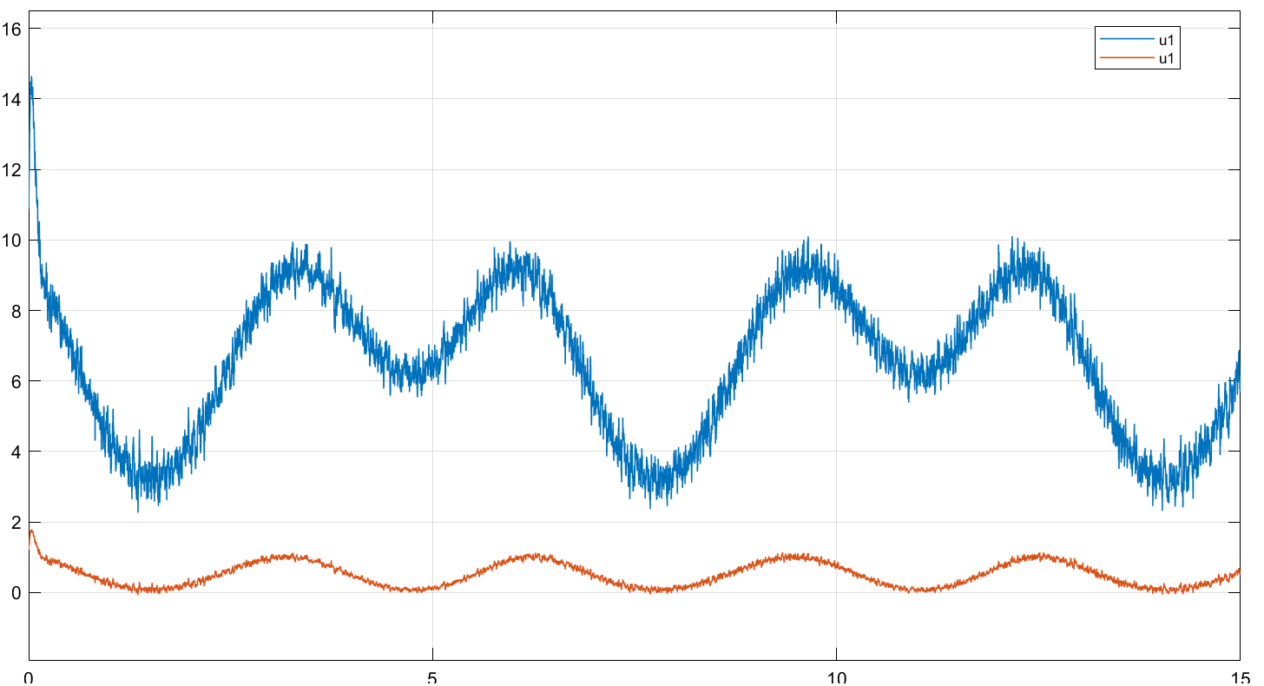

Figure 95: Inverse dynamics control realistic system sine wave response - joint input torque – with parameter deviation

### Observations

* Steady-state does not converges to zero anymore and tracking error is worse than when there is no parameter deviation

## Robust control

### Step response

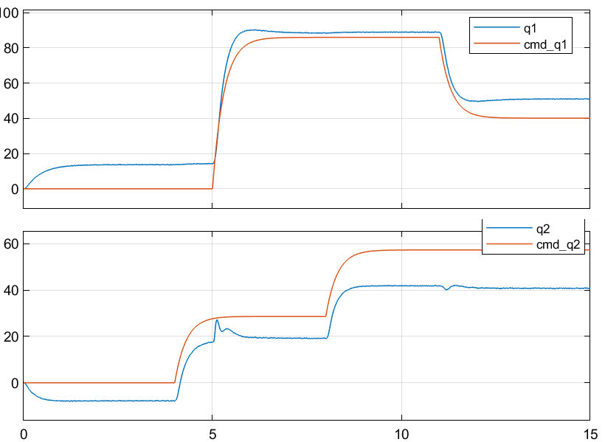

Figure 96: Robust control realistic system step response - joint position – with parameter deviation



Figure 97: Robust control realistic system step response - joint velocity– with parameter deviation



Figure 98: Robust control realistic system step response - joint input torque – with parameter deviation

### Sine wave response





Figure 99: Robust control realistic system sine wave response - joint position – with parameter deviation



Figure 100: Robust control realistic system sine wave response - joint velocity – with parameter deviation



Figure 101: Robust control realistic system sine wave response - joint input torque – with parameter deviation

### Observations

* Bigger steady-state and tracking errors and it doesn’t seem to be robust against parameter deviation